Open-Source Ecosystem — Lesson Plan
Classification: UNCLASSIFIED

1. Administrative and metadata

1.1 Lesson title
Open-Source Ecosystem

1.2 Module length
60 minutes (1 hours)
Schedule slot is 60 minutes. Content-guide ~120 minutes includes the keyboard practice that follows.

1.3 Terminal and enabling learning objectives
- TLO-1: At the end of the Counterstrike Operator Course, students will possess the ability to conduct military tactical planning in the context of DCO-RA
- TLO-4: At the end of the Counterstrike Operator Course, students will be able to rapidly access and effect adversary infrastructure
- ELO-33: Understand how to conduct open-source research against threat actors.
- ELO-37: Identify key components of an open-source ecosystem

1.4 Prerequisites
- B02.M01: Information Gathering and Reconnaissance

2. Personnel, range, and environment

2.1 Instructor and cadre
- 1 × instructor (required)
- 0 × range_engineer (not_applicable: Lecture Module; no range engineer required)
- 0 × auditor (not_applicable: Not used by this course)
- 0 × oversight_officer (not_applicable: Not used by this course)

2.2 Materials and resources
Instructor resources and pre-class preparation
- Classroom projector and screen; whiteboard for the opening contract
- Parent or sibling briefs listed in this Module folder
- Live tabs and references already named in this file's header
- Do not project flags, tokens, or answer-key values
Student resources and environment
- Student brief, student guide, or homework file in this Module folder when present
- Assigned range, workstation, or lab stack named in the student-facing file
- No extra kit beyond what the student-facing file already lists

3. Assessment and evaluation
ELO | Method | Related Module | Criteria
ELO-33 | in-class Q&A | — | In-class questions and check on learning in the content guide.
ELO-37 | in-class Q&A | — | In-class questions and check on learning in the content guide.

4. Instructional delivery

4.1 Opening, attention grabber, and motivator

Option 1 (Interactive / Whiteboard / Kinesthetic)
- Say: "You already have ports and versions from active recon."
- Do: Put the lesson contract on the board. Keep products from the prerequisite Module available.
- Ask (Q): Hold up one service and version from your last Nmap run.
- Expected Response (A): Facilitation. Use the Say/Do already on this row; do not force a single keyed answer.

Option 2 (Digital Slide / Virtual / Slide Deck)
- Say: "You already have ports and versions from active recon."
- Show: The title slide and lesson objectives.
- Do: Confirm stations can open the required tool or file before the first teaching row.
- Ask (Q): Hold up one service and version from your last Nmap run.
- Expected Response (A): Facilitation. Use the Say/Do already on this row; do not force a single keyed answer.

4.2 Side-by-side table of instruction
Visual / Slide Asset | Instructional Delivery & Instructor Notes
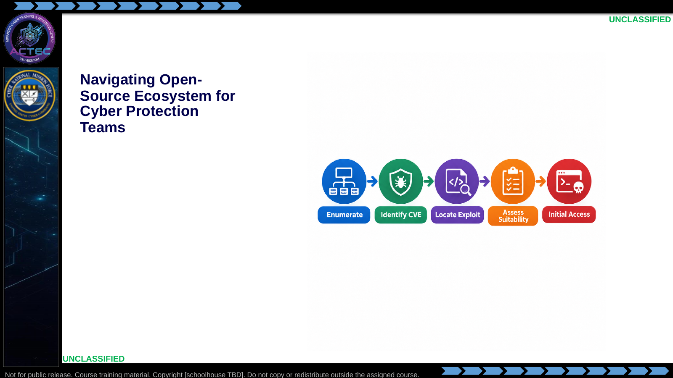  Slide 1: Navigating Open-Source Ecosystem for Cyber Protection Teams  Duration: 2 min | Say: - "You already have ports and versions from active recon."  - "This lesson turns that evidence into a deliberate exploit path."  - "We stay inside the open-source ecosystem: databases, repos, Searchsploit, Metasploit."  - "Goal is not 'run the first hit'—it is select, vet, and justify."  Show: - Trace the five-stage pipeline left to right.  Do: - Ask: "Hold up one service and version from your last Nmap run."  - Capture two examples on the board for the pipeline slides that follow.  Ask (Q): Hold up one service and version from your last Nmap run.  Expected Response (A): Facilitation. Use the Say/Do already on this row; do not force a single keyed answer.
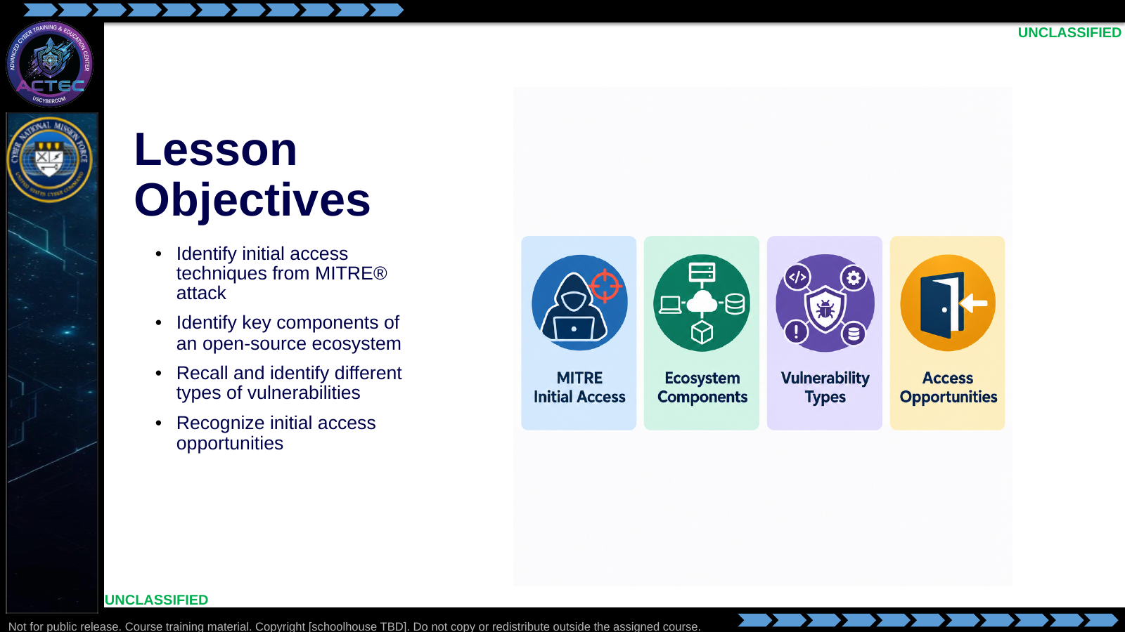  Slide 2: Lesson Objectives  Duration: 2 min | Say: - "Read these objectives as written—they are the contract for this block."  - "Identify initial access techniques from MITRE attack."  - "Identify key components of an open-source ecosystem."  - "Recall and identify different types of vulnerabilities."  - "Recognize initial access opportunities."  - "This block moves from passive leads and directly observed service/version evidence through vulnerability identification, exploit research, initial-access technique selection, and suitability assessment."  Show: - Point to each objective tile as you name the matching bullet.  Do: - Tell students to write their own one-line success check for each objective.  Ask (Q): What is the operational takeaway from this row?  Expected Response (A): Facilitation. Restate the Say/Do in operator terms. Do not invent a new teaching point.
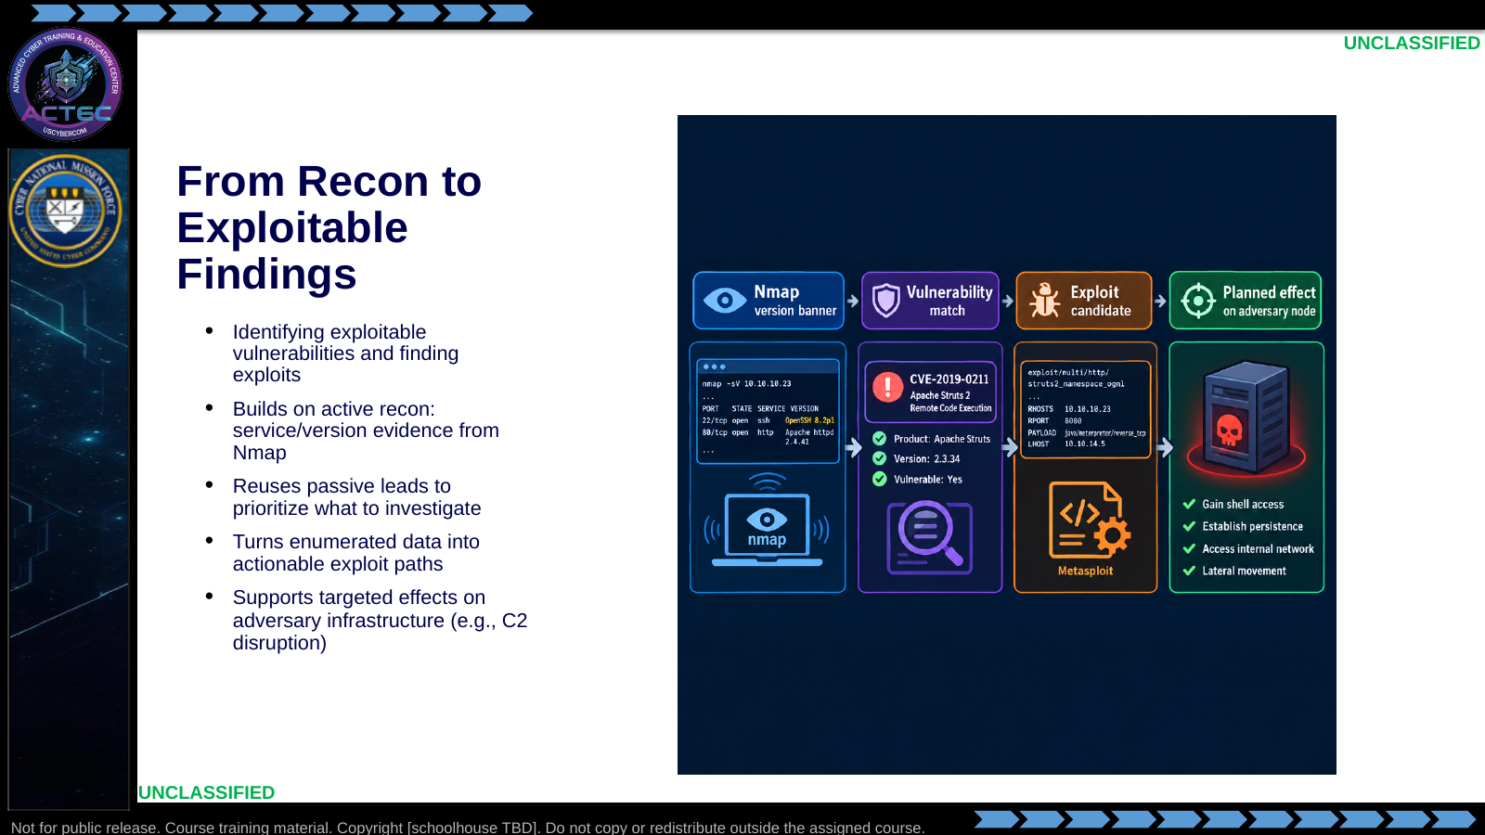  Slide 3: From Recon to Exploitable Findings  Duration: 2 min | Say: - "Passive leads prioritize where to look; Nmap gave you directly observed service and version evidence."  - "Start with that observed evidence: service and version."  - "Search for known weaknesses tied to that exact version."  - "Then locate working code or modules."  - "The point is a targeted path—not random scanning with exploit tools."  - "That path supports deliberate effects on adversary infrastructure."  Show: - Trace banner → match → candidate → effect.  Do: - Ask: "What version string from Nmap would you feed a search first?"  Ask (Q): What version string from Nmap would you feed a search first?  Expected Response (A): Facilitation. Use the Say/Do already on this row; do not force a single keyed answer.
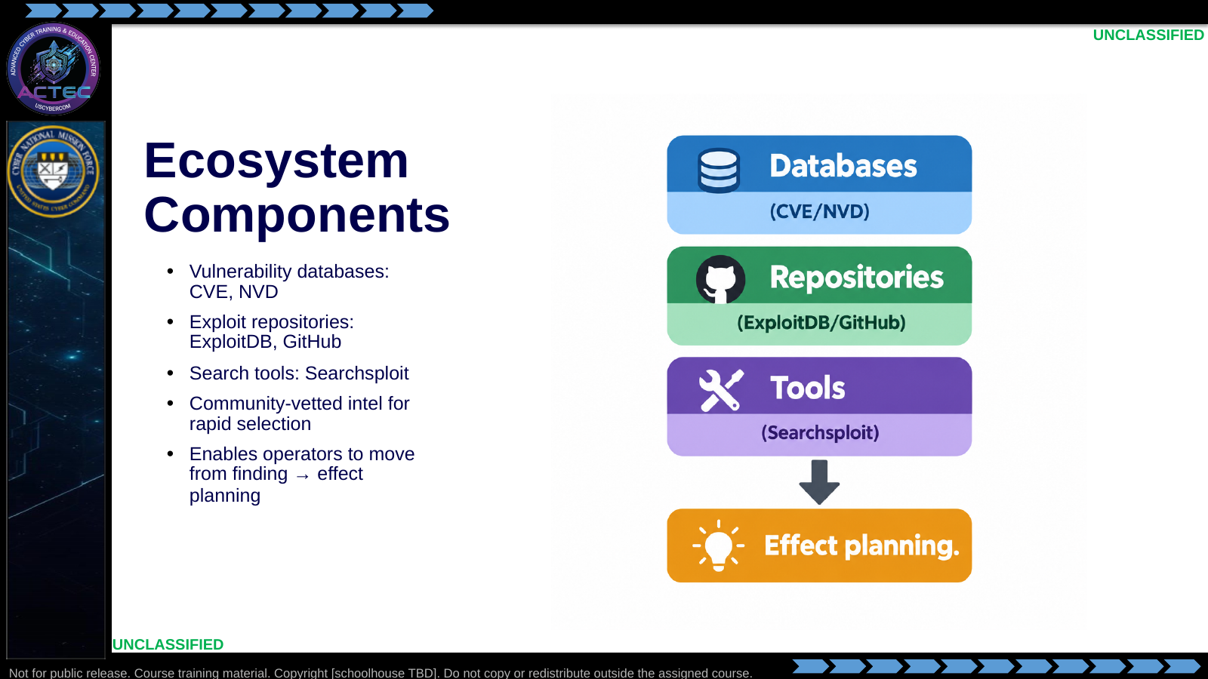  Slide 4: Ecosystem Components  Duration: 2 min | Say: - "Three layers."  - "Databases tell you what is wrong and how bad it is."  - "Repositories give you code and PoCs."  - "Searchsploit searches ExploitDB offline from the ops station."  - "You are not inventing vulns—you are navigating community work that already exists."  Show: - Point databases → repos → tools → planning.  Do: - Cold-call: "Name one item in each layer."  Ask (Q): What is the operational takeaway from this row?  Expected Response (A): Facilitation. Restate the Say/Do in operator terms. Do not invent a new teaching point.
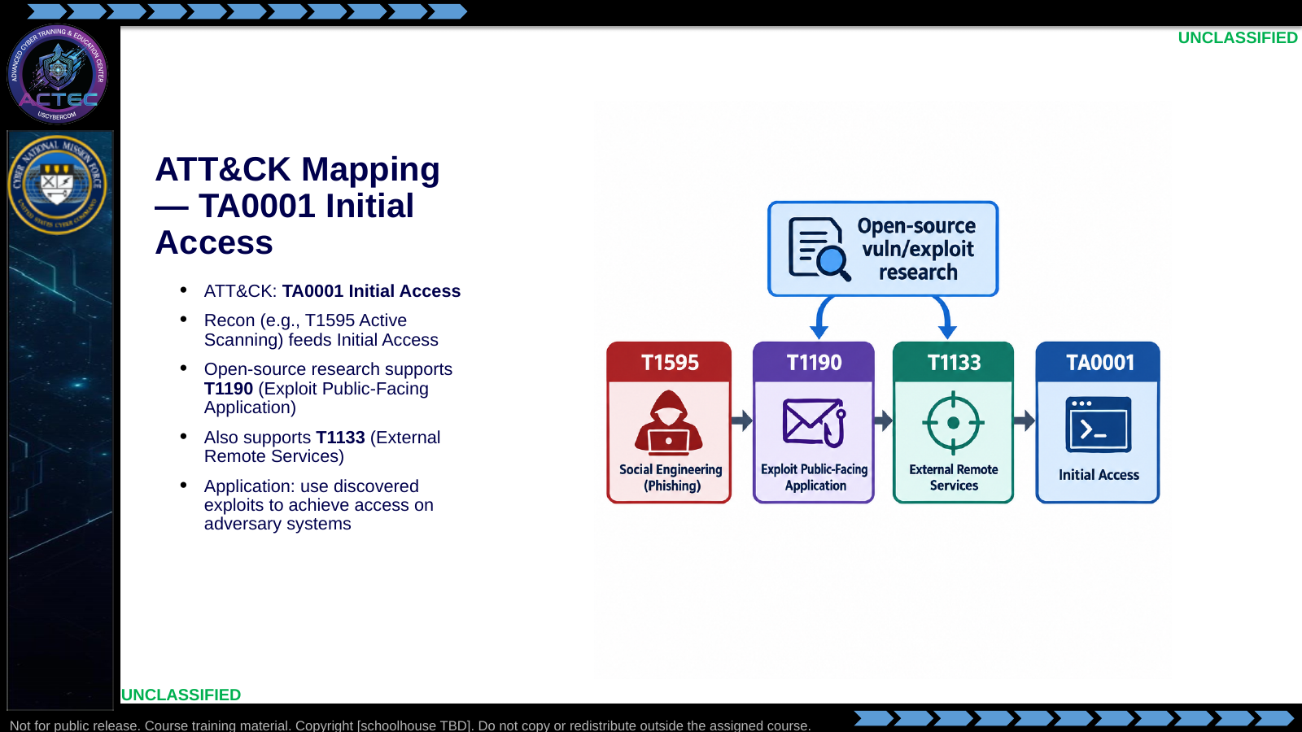  Slide 5: ATT&CK Mapping — TA0001 Initial Access  Duration: 2 min | Say: - "ATT&CK language stays consistent with the planning pipeline."  - "Active scanning produced the versions."  - "This lesson feeds Initial Access—especially public-facing apps and external remote services."  - "You reverse the adversary playbook: same techniques, aimed at their exposed stack."  Show: - Point T1595 into TA0001, then highlight T1190 and T1133.  Do: - Ask: "Which of your enumerated ports is more T1190 versus T1133?"  Ask (Q): Which of your enumerated ports is more T1190 versus T1133?  Expected Response (A): Facilitation. Use the Say/Do already on this row; do not force a single keyed answer.
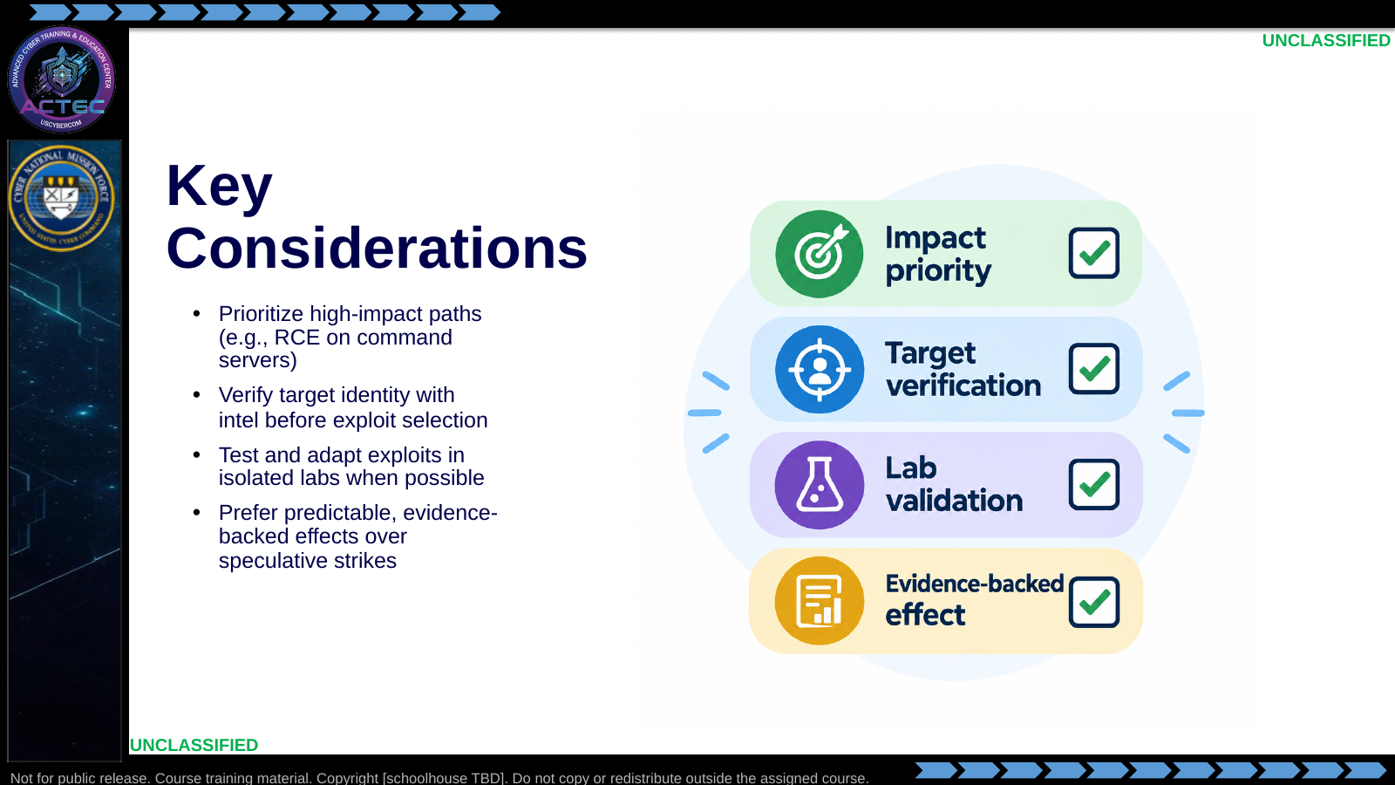  Slide 6: Key Considerations  Duration: 2 min | Say: - "Four operator filters before you touch exploit code."  - "Impact: does this path actually matter to the adversary mission?"  - "Verification: does intel and recon agree this is the right node?"  - "Validation: can you prove behavior in a lab first?"  - "Evidence: can you report what changed afterward?"  - "Keep selection tied to mission effect—not novelty of the CVE."  Show: - Tick each checklist item aloud.  Do: - Ask students to rank the four filters for a time-sensitive disruption; take disagreement and resolve toward mission fit.  Ask (Q): What is the operational takeaway from this row?  Expected Response (A): Facilitation. Restate the Say/Do in operator terms. Do not invent a new teaching point.
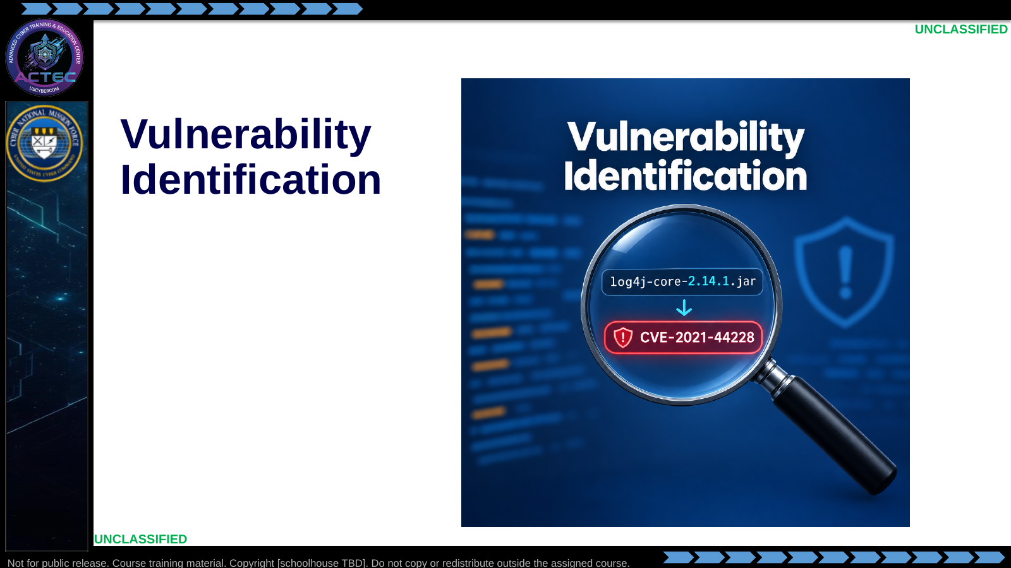  Slide 7: Vulnerability Identification  Duration: 2 min | Say: - "We now turn observed service and version evidence into vulnerability candidates."  Show: - Hold on the version-to-CVE visual, then advance.  Do: - Have students keep one observed version ready for the next example.  Ask (Q): What is the operational takeaway from this row?  Expected Response (A): Facilitation. Restate the Say/Do in operator terms. Do not invent a new teaching point.
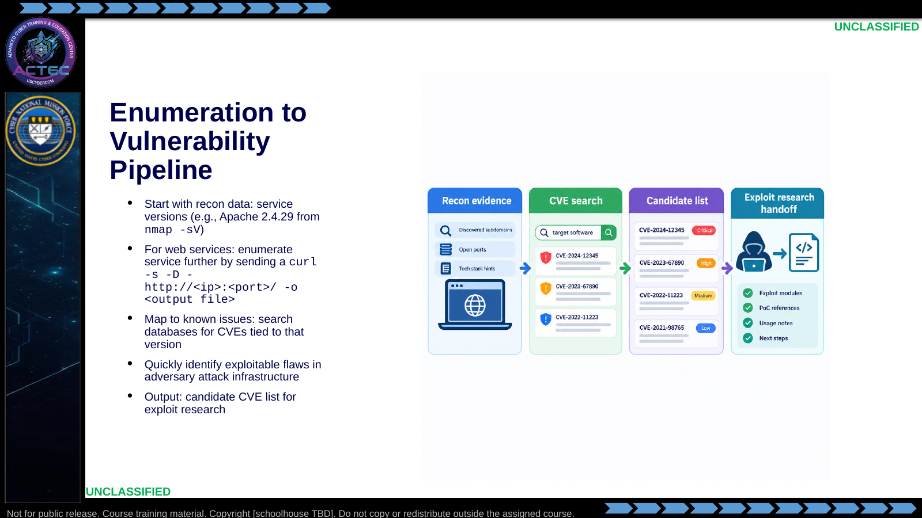  Slide 8: Enumeration to Vulnerability Pipeline  Duration: 2 min | Say: - "Pipeline, not luck."  - "Banner or script output is the query key."  - "Search NVD/CVE (and later ExploitDB) for that product and version."  - "You leave this step with candidates—not a guaranteed shell."  Show: - Walk the four cards.  Do: - Write Apache 2.4.29 on the board as the running query key.  Ask (Q): What is the operational takeaway from this row?  Expected Response (A): Facilitation. Restate the Say/Do in operator terms. Do not invent a new teaching point.
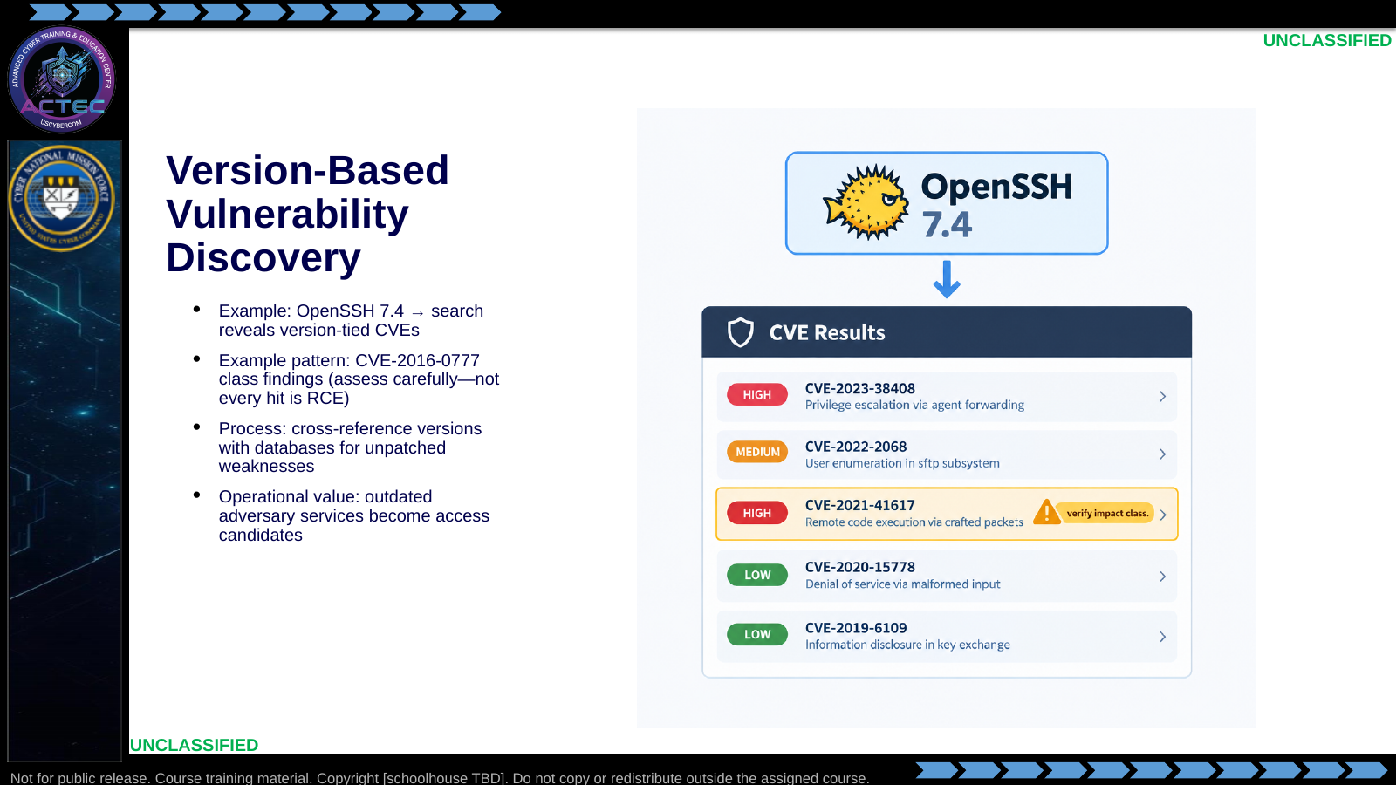  Slide 9: Version-Based Vulnerability Discovery  Duration: 2 min | Say: - "Exact version matching beats fuzzy product-only searches."  - "OpenSSH 7.4 is the pattern: version in, CVE list out."  - "Read the impact class—information leak is not the same as RCE."  - "Unpatched legacy on adversary infrastructure is often your best first look."  Show: - Point at the caution badge on impact class.  Do: - Ask: "What would you record besides the CVE ID?" Prompt for CVSS, auth required, remote/local.  Ask (Q): What would you record besides the CVE ID?  Expected Response (A): Facilitation. Use the Say/Do already on this row; do not force a single keyed answer.
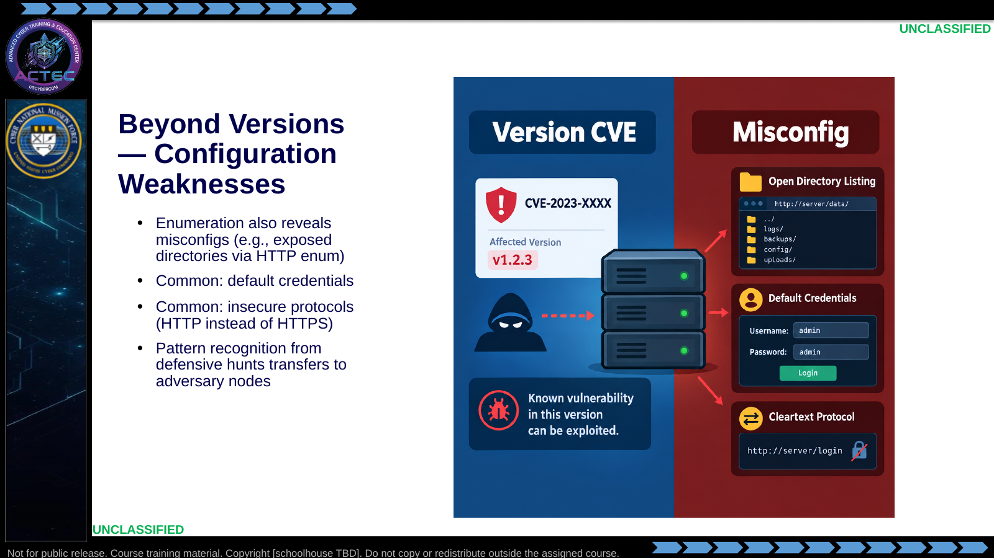  Slide 10: Beyond Versions — Configuration Weaknesses  Duration: 2 min | Say: - "Not every access path is a CVE."  - "Misconfiguration is still a vulnerability class."  - "Default credentials and cleartext services show up in enum just like versions do."  - "Hunt experience helps: the same weak patterns you see on blue hosts appear on adversary nodes."  Show: - Contrast version CVE vs misconfig panels.  Do: - Ask for one misconfig they have already seen in labs or hunts.  Ask (Q): What is the operational takeaway from this row?  Expected Response (A): Facilitation. Restate the Say/Do in operator terms. Do not invent a new teaching point.
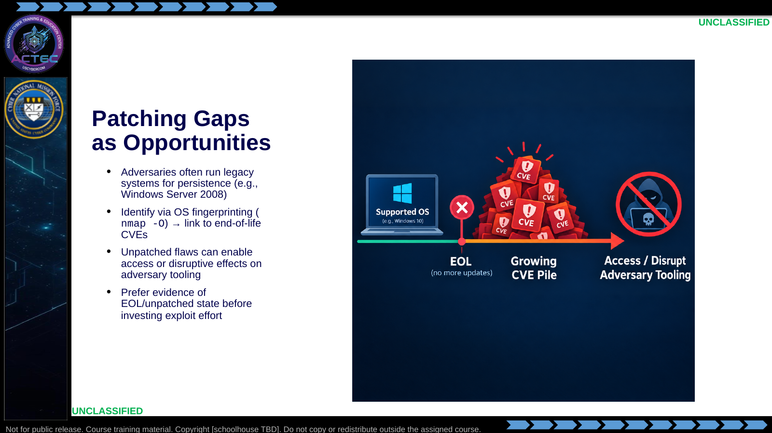  Slide 11: Patching Gaps as Opportunities  Duration: 2 min | Say: - "Legacy and EOL systems accumulate public exploit coverage."  - "OS fingerprinting is a clue, not proof—verify with service banners when you can."  - "Patch gaps are opportunities when the version and exposure match."  - "Do not assume 'old' equals 'exploitable today' without a matching public path."  Show: - Trace EOL → CVE pile → opportunity.  Do: - Ask: "How would you distinguish a fingerprint guess from a banner-verified version?"  Ask (Q): How would you distinguish a fingerprint guess from a banner-verified version?  Expected Response (A): Facilitation. Use the Say/Do already on this row; do not force a single keyed answer.
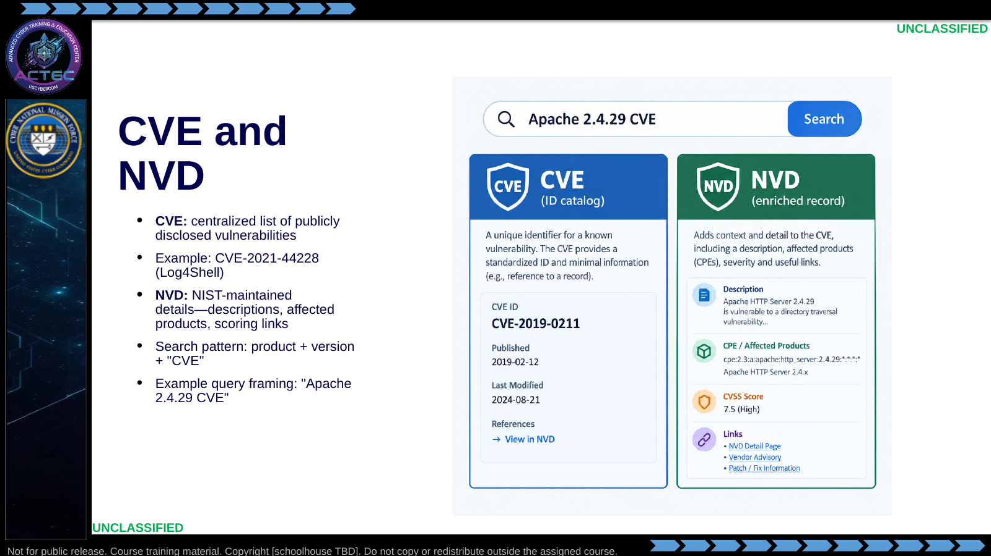  Slide 12: CVE and NVD  Duration: 2 min | Say: - "CVE is the shared ID language."  - "NVD adds the operator-useful detail: what is affected and how it is described."  - "Search with product and version, not vibes."  - "Log4Shell is the famous example of a CVE ID everyone recognizes—use the same discipline for boring CVEs too."  Show: - Point CVE ID card, then NVD enrichment card.  Do: - Have students write one search string for their board version example.  Ask (Q): What is the operational takeaway from this row?  Expected Response (A): Facilitation. Restate the Say/Do in operator terms. Do not invent a new teaching point.
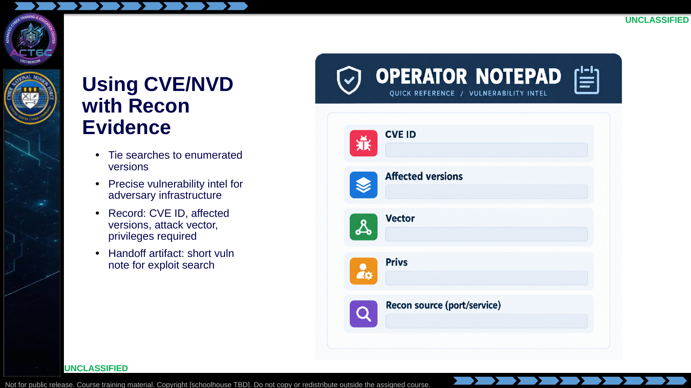  Slide 13: Using CVE/NVD with Recon Evidence  Duration: 2 min | Say: - "Recon evidence is the filter that makes NVD useful."  - "If the affected version range misses your banner, discard the candidate."  - "Capture vector and privilege needs now—they drive suitability later."  - "Your handoff is a short note, not a screenshot dump."  Show: - Walk each notepad field.  Do: - Fill one example note together from the Apache/OpenSSH board examples.  Ask (Q): What is the operational takeaway from this row?  Expected Response (A): Facilitation. Restate the Say/Do in operator terms. Do not invent a new teaching point.
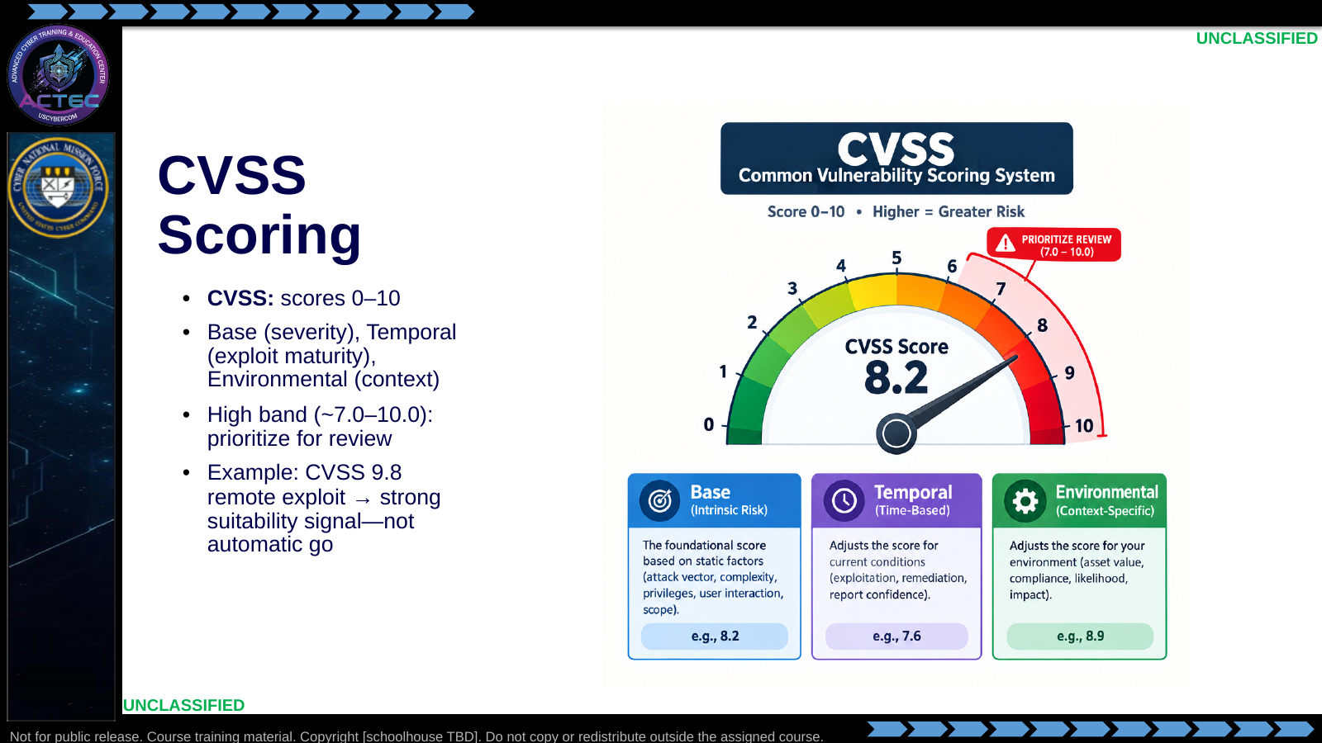  Slide 14: CVSS Scoring  Duration: 2 min | Say: - "CVSS ranks severity and context—it does not replace suitability assessment."  - "Base tells you inherent severity."  - "Temporal reflects exploit maturity over time."  - "Environmental is where your target context matters."  - "High scores earn review priority, not blind execution."  Show: - Point at the three metric groups and the high band.  Do: - Ask: "When would you skip a 9.8?" Prompt for auth required, local-only, wrong version, noisy crash risk.  Ask (Q): When would you skip a 9.8?  Expected Response (A): Facilitation. Use the Say/Do already on this row; do not force a single keyed answer.
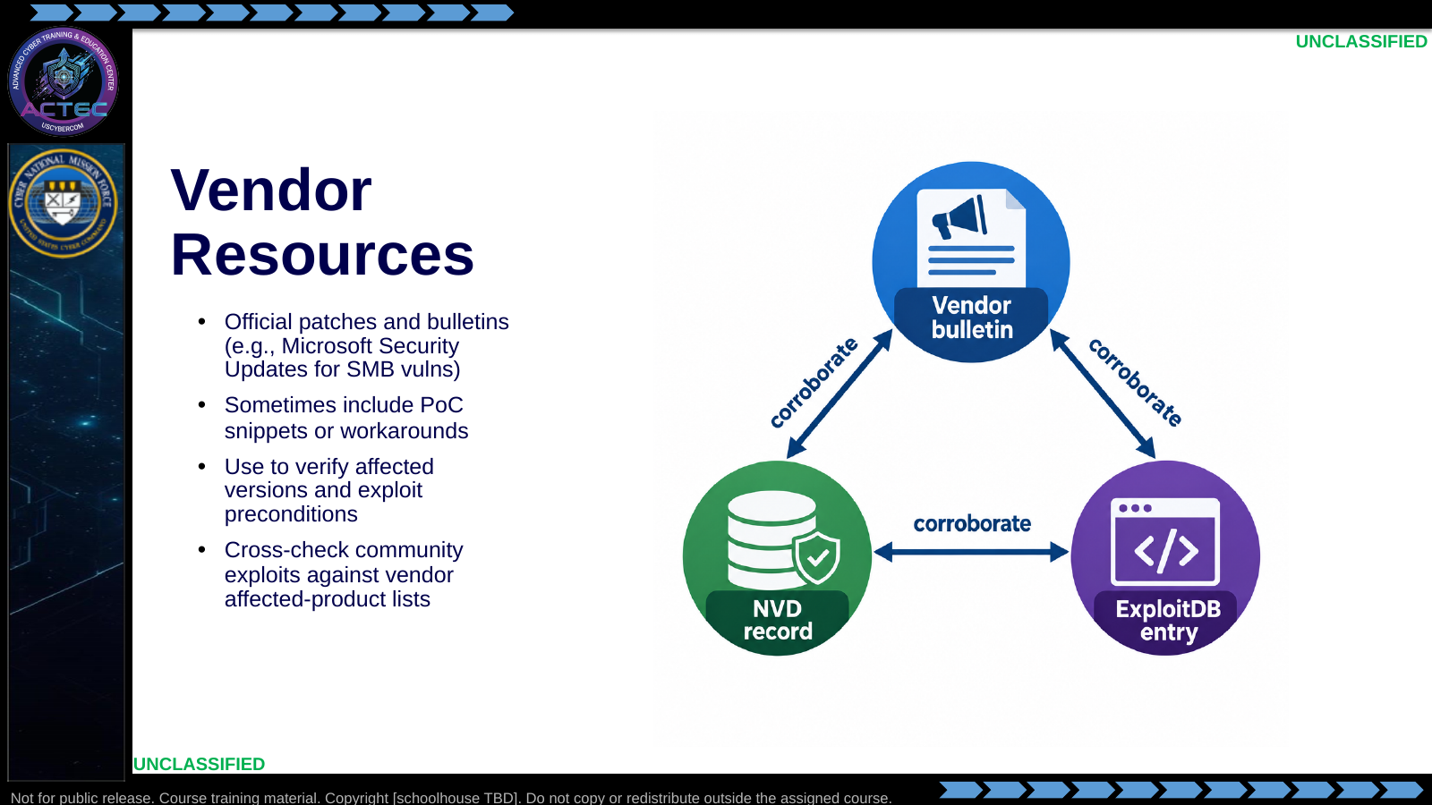  Slide 15: Vendor Resources  Duration: 2 min | Say: - "Vendor write-ups verify scope and sometimes preconditions."  - "They are slower to give full exploit code—but strong for version truth."  - "Corroborate community exploits against vendor affected lists."  - "If vendor says not affected, stop and re-check your banner."  Show: - Trace corroboration triangle.  Do: - Ask: "What would you trust first if ExploitDB and vendor disagree on affected versions?"  Ask (Q): What would you trust first if ExploitDB and vendor disagree on affected versions?  Expected Response (A): Facilitation. Use the Say/Do already on this row; do not force a single keyed answer.
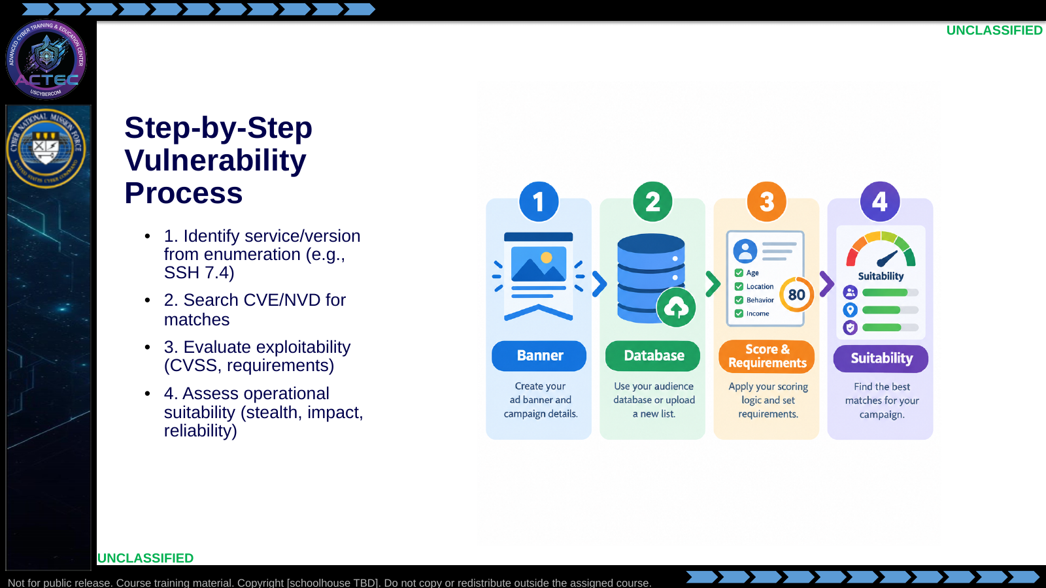  Slide 16: Step-by-Step Vulnerability Process  Duration: 2 min | Say: - "Memorize the order."  - "Version first."  - "Database match second."  - "Exploitability third."  - "Suitability fourth—before you run anything."  - "Skipping to 'run module' is how you crash the wrong thing."  Show: - Tap each step in order.  Do: - Students recite the four steps to a partner in 20 seconds.  Ask (Q): What is the operational takeaway from this row?  Expected Response (A): Facilitation. Restate the Say/Do in operator terms. Do not invent a new teaching point.
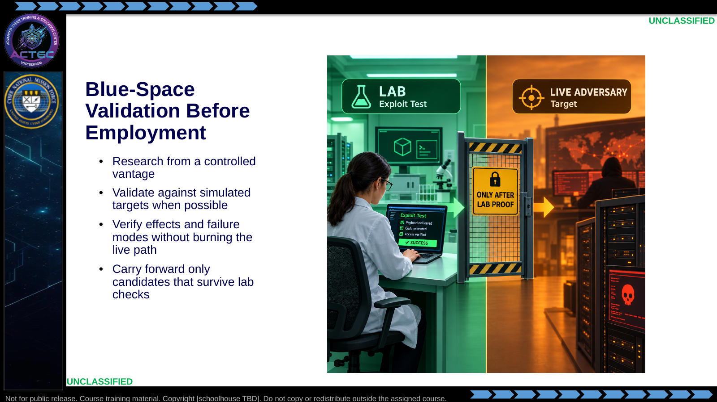  Slide 17: Blue-Space Validation Before Employment  Duration: 2 min | Say: - "Blue-space advantage is controlled testing."  - "Prove crash versus shell in the lab."  - "Prove options and callbacks before live employment."  - "If it only works once by luck, it is not ready."  Show: - Point at the gate between lab and live.  Do: - Tie forward: Searchsploit judgment and Metasploit keyboard practice are the proving ground for this lecture.  Ask (Q): What is the operational takeaway from this row?  Expected Response (A): Facilitation. Restate the Say/Do in operator terms. Do not invent a new teaching point.
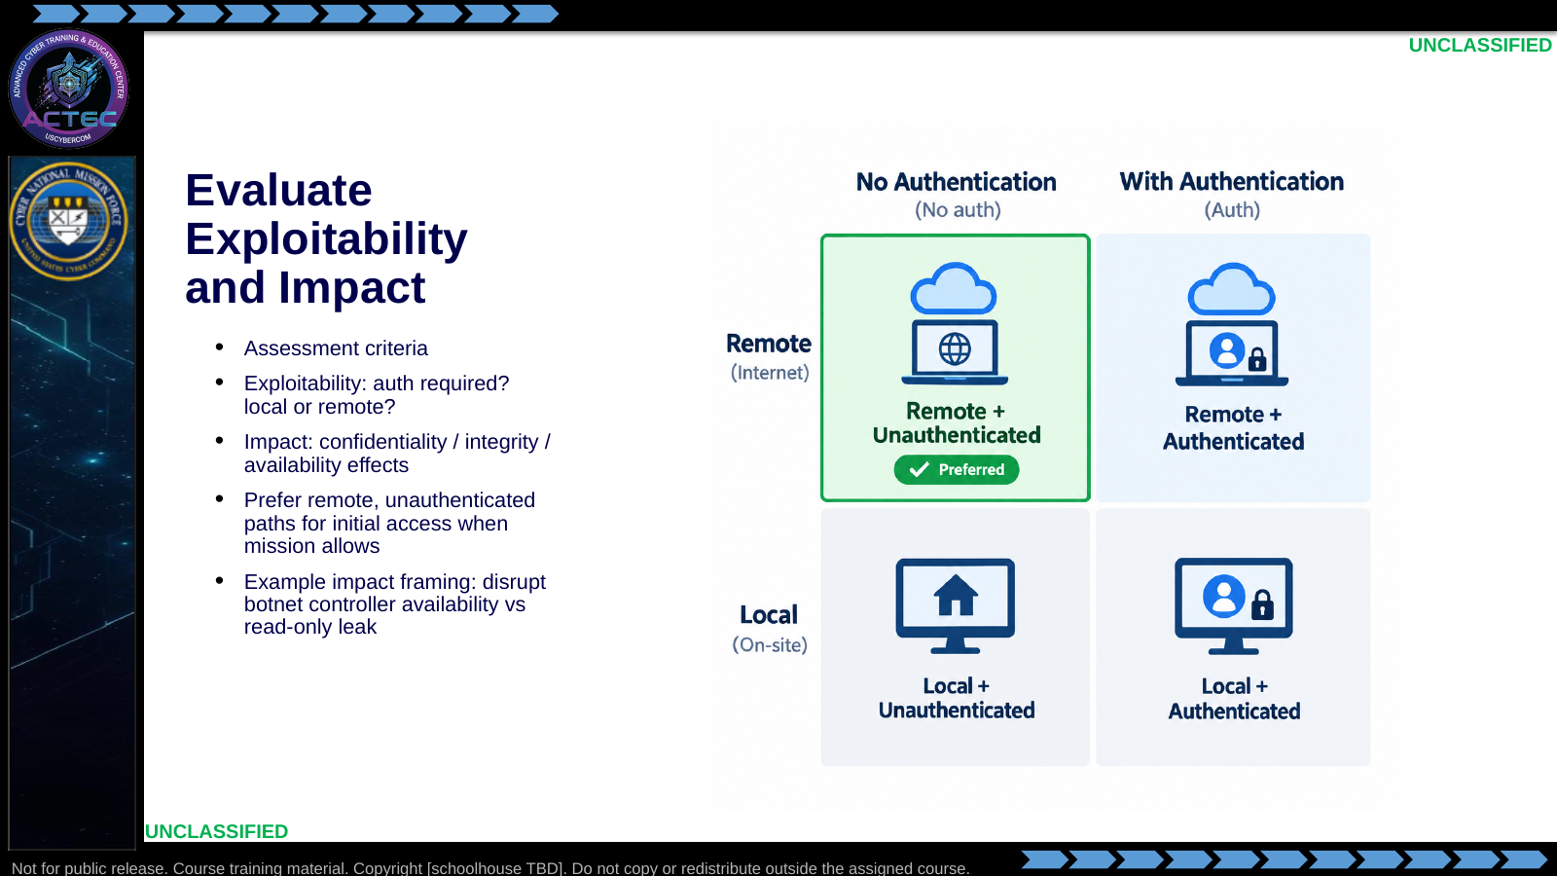  Slide 18: Evaluate Exploitability and Impact  Duration: 2 min | Say: - "Exploitability is requirements."  - "Impact is what breaks for the adversary."  - "For initial access, remote and unauthenticated usually wins the first pass."  - "A local privilege bug may be useless until you already have a session."  - "Match impact language to mission: access, disrupt, deny—not 'pwned.'"  Show: - Highlight the preferred matrix cell; note exceptions.  Do: - Give a local-only CVE and ask whether it belongs in the initial-access shortlist.  Ask (Q): What is the operational takeaway from this row?  Expected Response (A): Facilitation. Restate the Say/Do in operator terms. Do not invent a new teaching point.
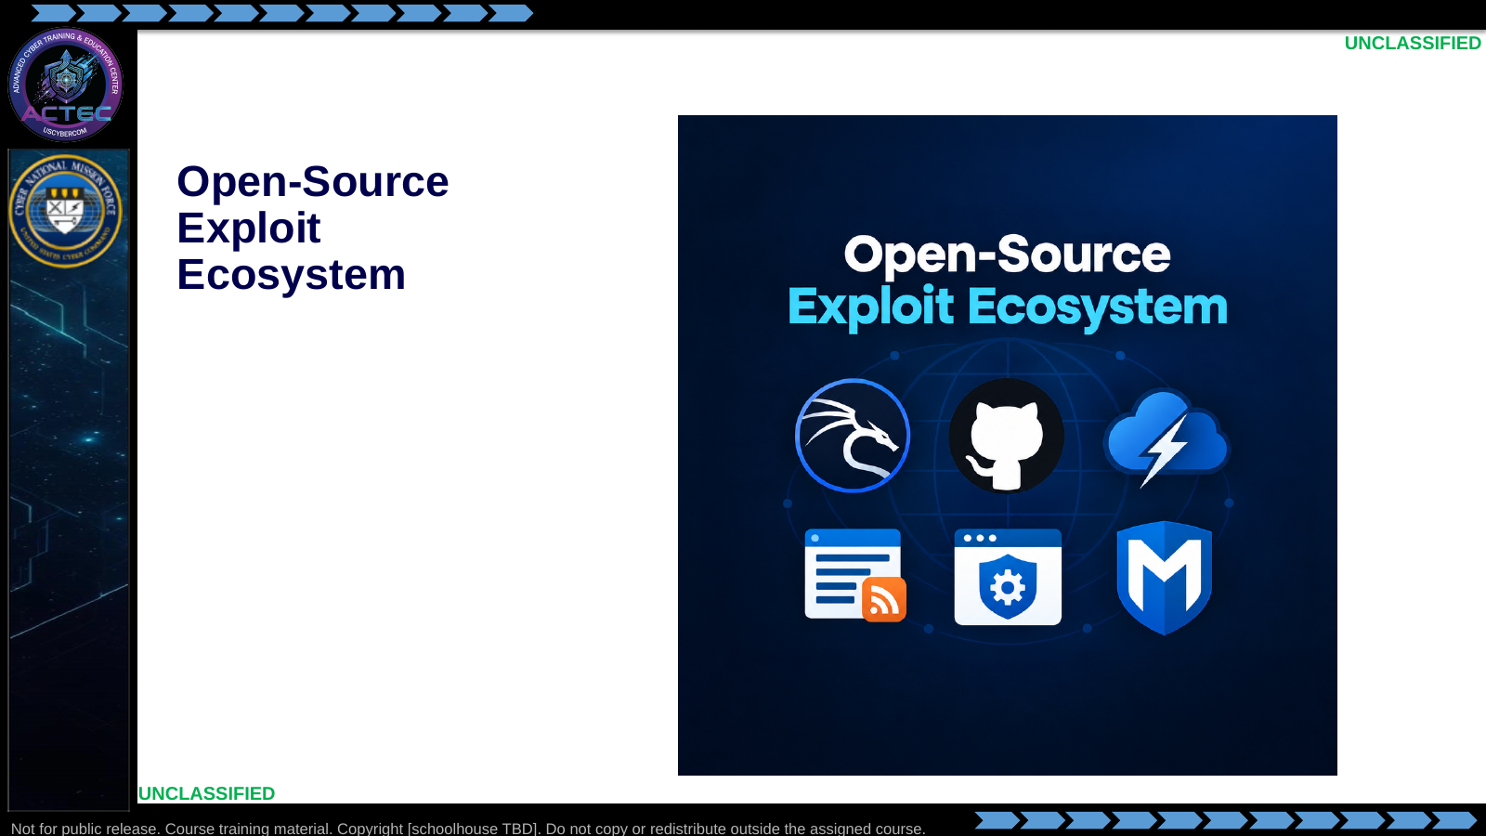  Slide 19: Open-Source Exploit Ecosystem  Duration: 2 min | Say: - "A candidate CVE is a lead; this block is about finding and vetting the code or framework that might apply."  Show: - Hold on the source icons, then advance.  Do: - Ask students to name one source they would use after checking a vendor advisory.  Ask (Q): What is the operational takeaway from this row?  Expected Response (A): Facilitation. Restate the Say/Do in operator terms. Do not invent a new teaching point.
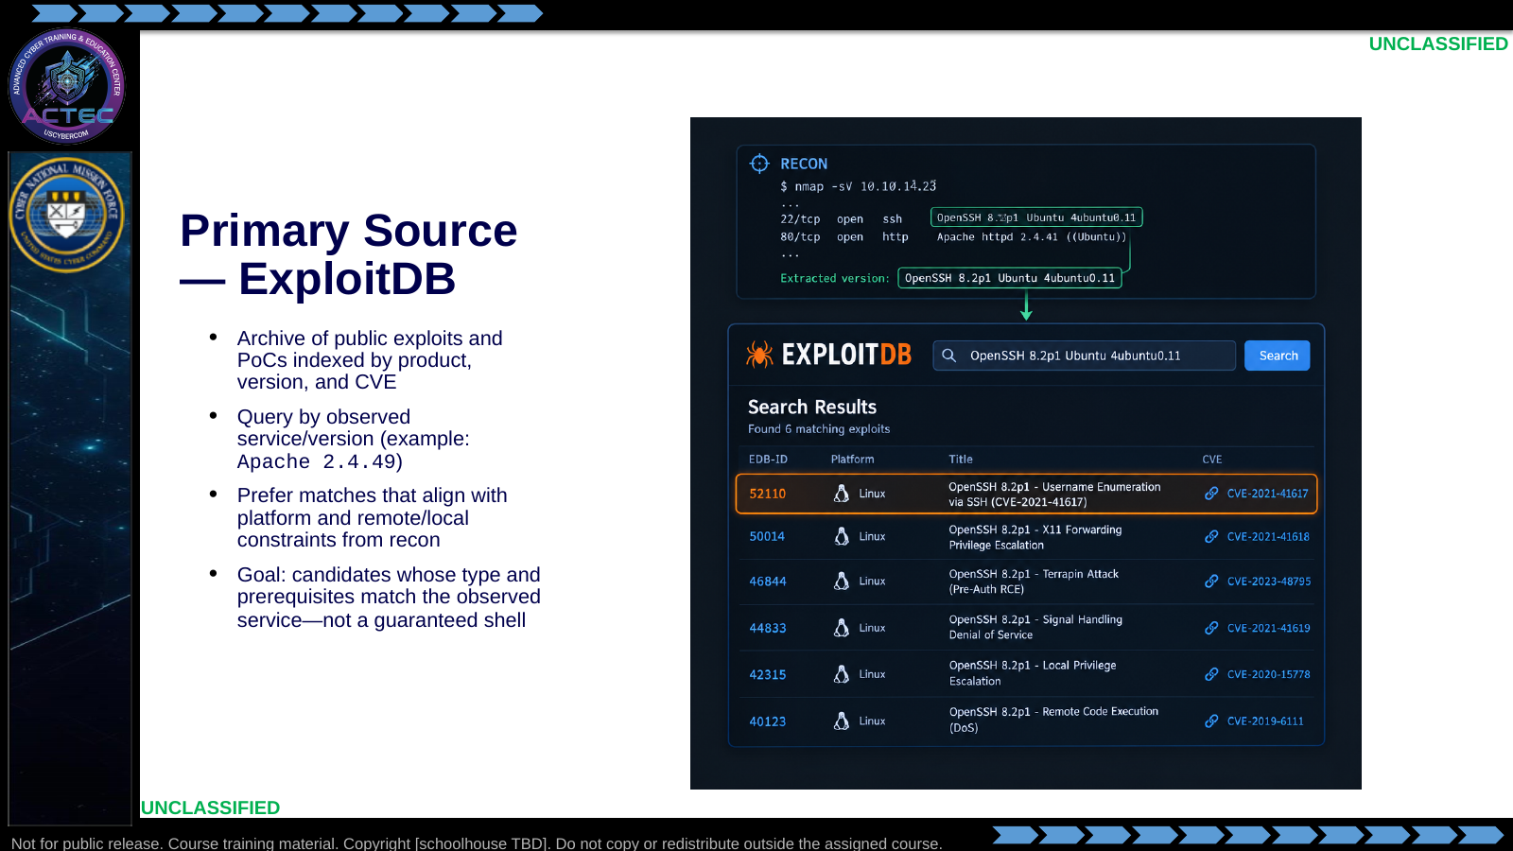  Slide 20: Primary Source — ExploitDB  Duration: 2 min | Say: - "You already used version evidence to find CVE candidates; ExploitDB is often the first place to look for public code tied to those findings."  - "Search with the product and version you observed—not a vague product name alone."  - "Read platform and exploit type before you copy anything."  - "A hit is a candidate. Lab validation still decides employment."  Show: - Point from the recon version string into the highlighted result row.  Do: - Ask: "If ExploitDB and the vendor advisory disagree on affected versions, which do you trust first?"  Ask (Q): If ExploitDB and the vendor advisory disagree on affected versions, which do you trust first?  Expected Response (A): Facilitation. Use the Say/Do already on this row; do not force a single keyed answer.
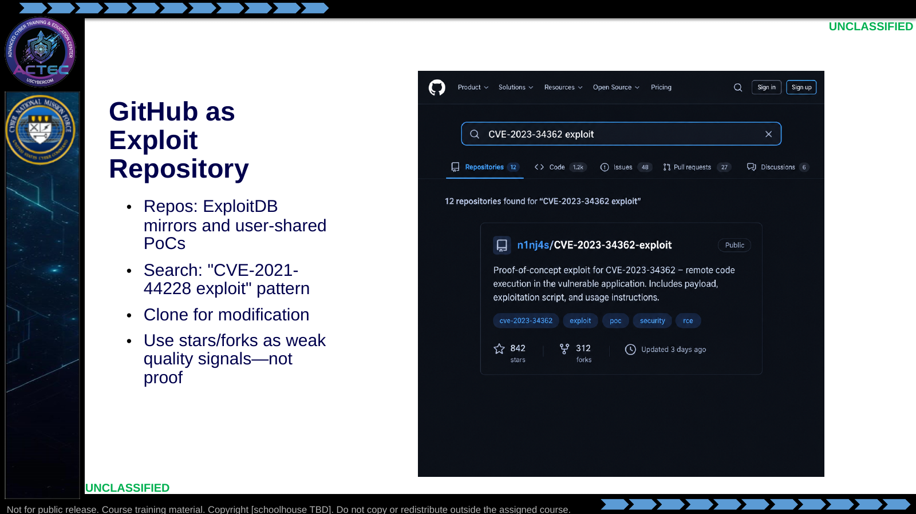  Slide 21: GitHub as Exploit Repository  Duration: 2 min | Say: - "GitHub is fast and uneven."  - "Great for recent PoCs and variants."  - "Stars help triage; they do not certify safety or correctness."  - "Always read the code before you run it."  Show: - Point at stars/forks/last update fields.  Do: - Ask: "What would make you reject a high-star repo immediately?"  Ask (Q): What would make you reject a high-star repo immediately?  Expected Response (A): Facilitation. Use the Say/Do already on this row; do not force a single keyed answer.
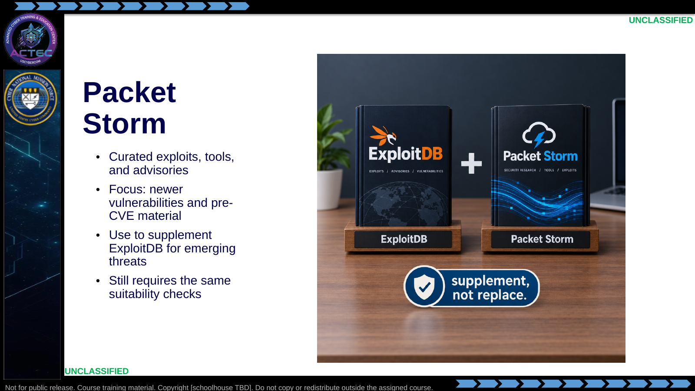  Slide 22: Packet Storm  Duration: 2 min | Say: - "Packet Storm is a secondary shelf."  - "Useful when ExploitDB is thin on a new issue."  - "Pre-CVE content can be noisy—verify against your version evidence."  Show: - Emphasize supplement badge.  Do: - Note: course labs primarily use Searchsploit/MSF; Packet Storm is awareness.  Ask (Q): What is the operational takeaway from this row?  Expected Response (A): Facilitation. Restate the Say/Do in operator terms. Do not invent a new teaching point.
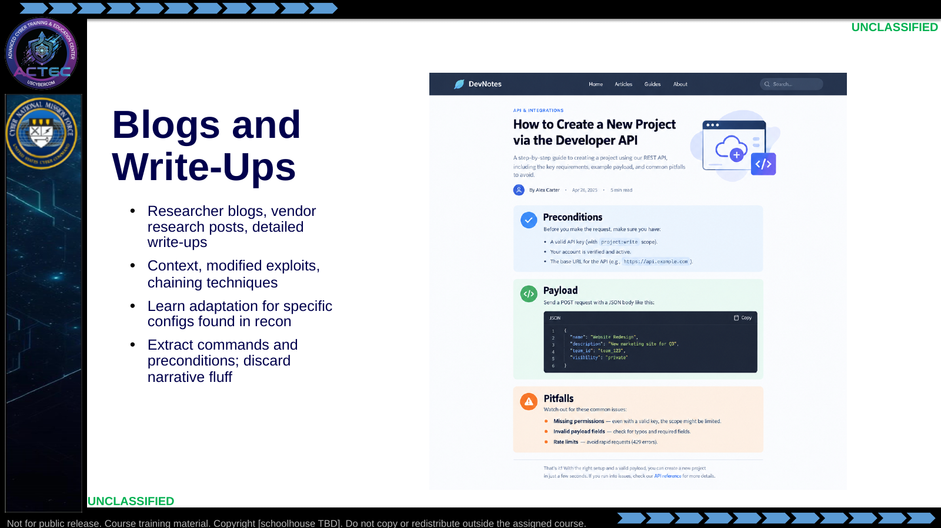  Slide 23: Blogs and Write-Ups  Duration: 2 min | Say: - "Write-ups teach adaptation."  - "You want preconditions and failure modes, not hype."  - "Chaining ideas matter when one CVE is not enough."  - "Translate blog steps into your own checklist."  Show: - Highlight Preconditions / Payload / Pitfalls.  Do: - Ask students what pitfall they would record from a write-up before testing.  Ask (Q): What is the operational takeaway from this row?  Expected Response (A): Facilitation. Restate the Say/Do in operator terms. Do not invent a new teaching point.
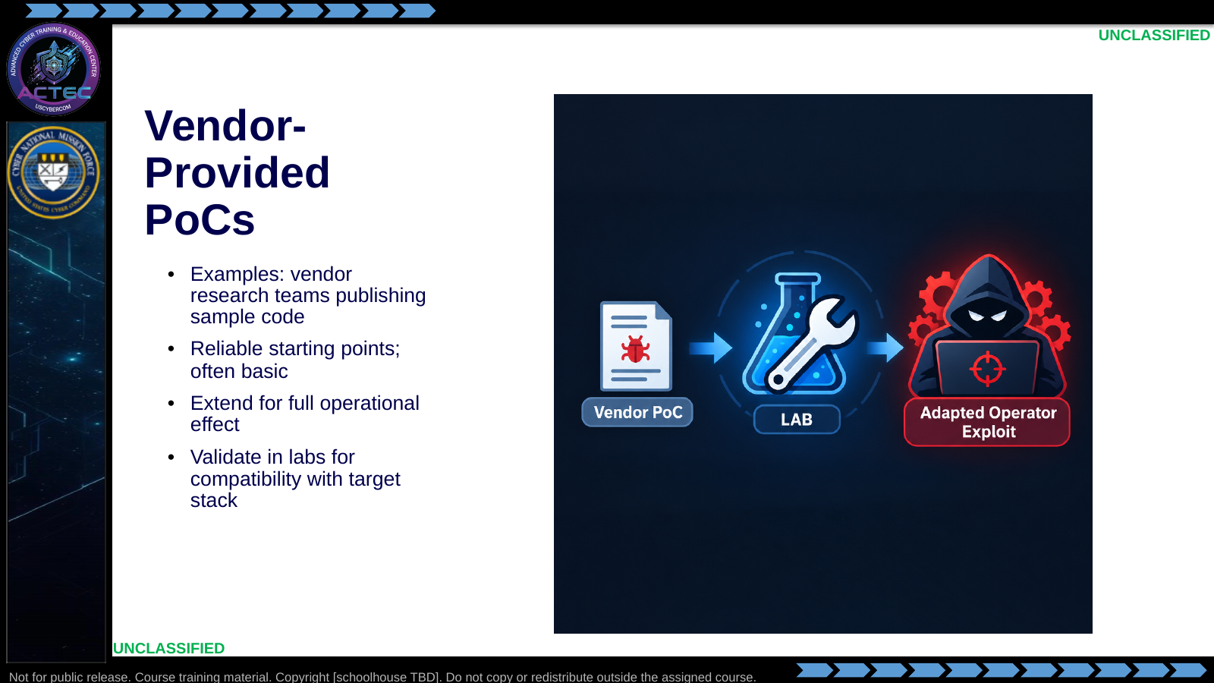  Slide 24: Vendor-Provided PoCs  Duration: 2 min | Say: - "Vendor PoCs are usually cleaner and narrower."  - "They prove the bug more than they deliver a full kit."  - "Expect to extend payloads and options."  - "Lab validation still required."  Show: - Show small PoC → adapted path.  Do: - Contrast: vendor PoC vs random GitHub one-liner—what differs in trust?  Ask (Q): What is the operational takeaway from this row?  Expected Response (A): Facilitation. Restate the Say/Do in operator terms. Do not invent a new teaching point.
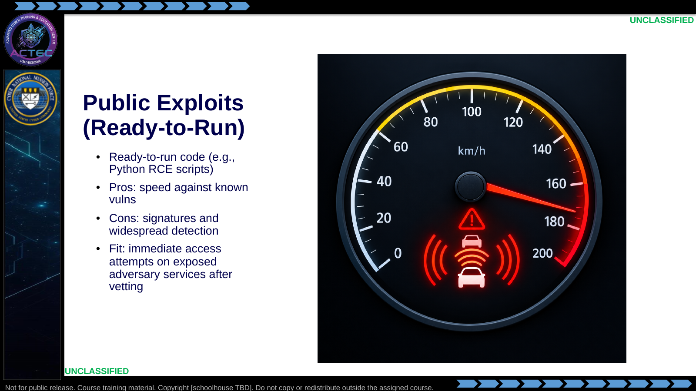  Slide 25: Public Exploits (Ready-to-Run)  Duration: 2 min | Say: - "Public ready-to-run code is fast."  - "It is also well known to defenders and vendors."  - "Use when speed beats novelty and you accept signature risk."  - "Still read it—malware in 'exploit' wrappers exists."  Show: - Balance speed vs detection.  Do: - Ask when they would choose a quieter modified PoC instead.  Ask (Q): What is the operational takeaway from this row?  Expected Response (A): Facilitation. Restate the Say/Do in operator terms. Do not invent a new teaching point.
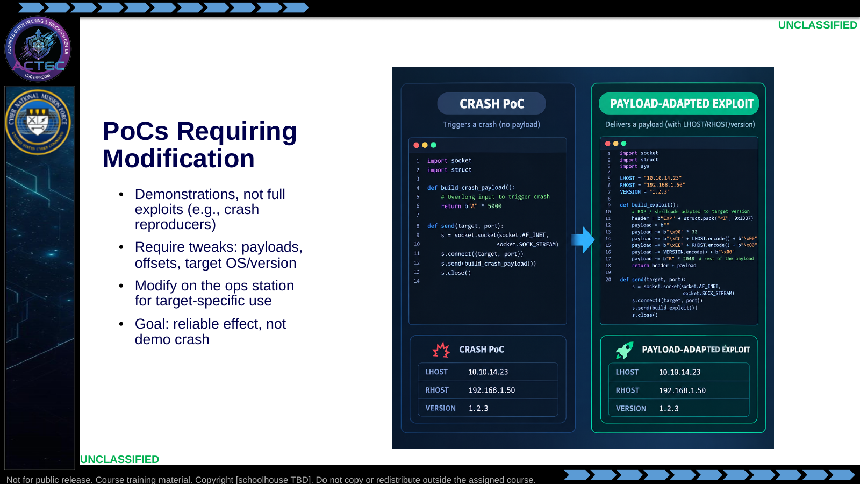  Slide 26: PoCs Requiring Modification  Duration: 2 min | Say: - "Many 'exploits' only prove a crash."  - "Your job is to adapt toward the intended effect."  - "Match OS, arch, paths, and callback addresses."  - "If you cannot explain the change, do not run it live."  Show: - Point at the fields that usually need edits.  Do: - Preview keyboard practice: inspect script variables before execution.  Ask (Q): What is the operational takeaway from this row?  Expected Response (A): Facilitation. Restate the Say/Do in operator terms. Do not invent a new teaching point.
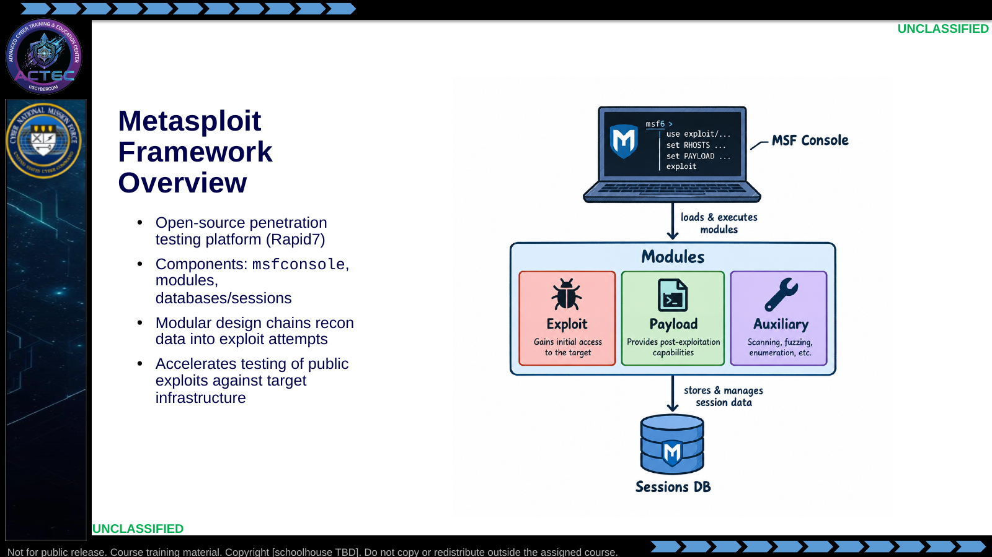  Slide 27: Metasploit Framework Overview  Duration: 2 min | Say: - "Metasploit packages a large share of public exploit work into modules."  - "Console is the operator interface."  - "Modules are the weapons; payloads are what you deliver; auxiliaries help enum/check."  - "It speeds disciplined testing—it does not remove suitability judgment."  Show: - Walk console → modules → sessions.  Do: - Point ahead to Metasploit as the hands-on proving ground for these families.  Ask (Q): What is the operational takeaway from this row?  Expected Response (A): Facilitation. Restate the Say/Do in operator terms. Do not invent a new teaching point.
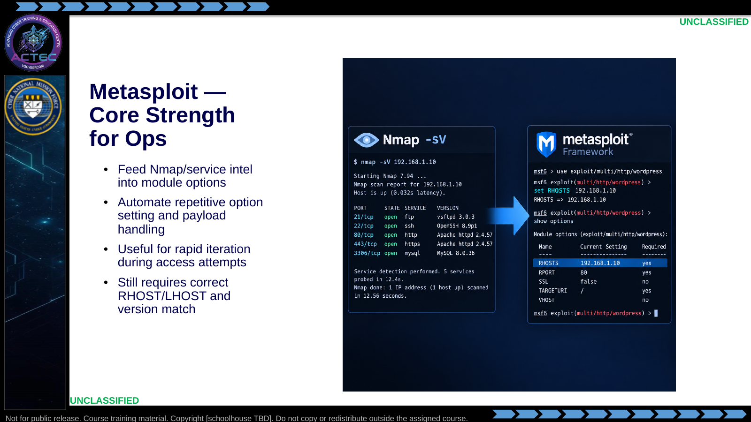  Slide 28: Metasploit — Core Strength for Ops  Duration: 2 min | Say: - "Strength is integration and speed."  - "Your recon notes become module options."  - "Wrong LHOST still fails the best module."  - "Version mismatch still fails EternalBlue-class paths."  Show: - Trace Nmap → set options.  Do: - Ask: "What is your callback interface on Academy VPN?" (expect tun0 / lab-specific)  Ask (Q): What is your callback interface on Academy VPN?  Expected Response (A): Facilitation. Use the Say/Do already on this row; do not force a single keyed answer.
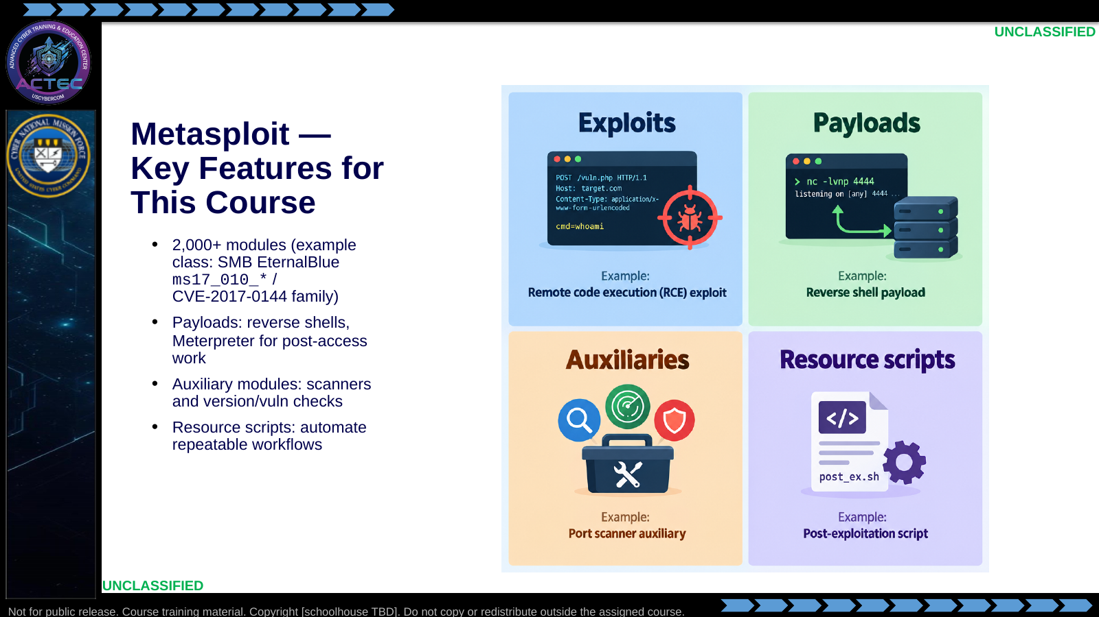  Slide 29: Metasploit — Key Features for This Course  Duration: 2 min | Say: - "You will touch all four families in later Metasploit practice."  - "Exploits get you in."  - "Payloads define the session you catch."  - "Auxiliaries verify before you burn an exploit."  - "Resource scripts save time on repeat targets."  Show: - Tap each tile.  Do: - Tell students to note one example module name during the next lab for their journal.  Ask (Q): What is the operational takeaway from this row?  Expected Response (A): Facilitation. Restate the Say/Do in operator terms. Do not invent a new teaching point.
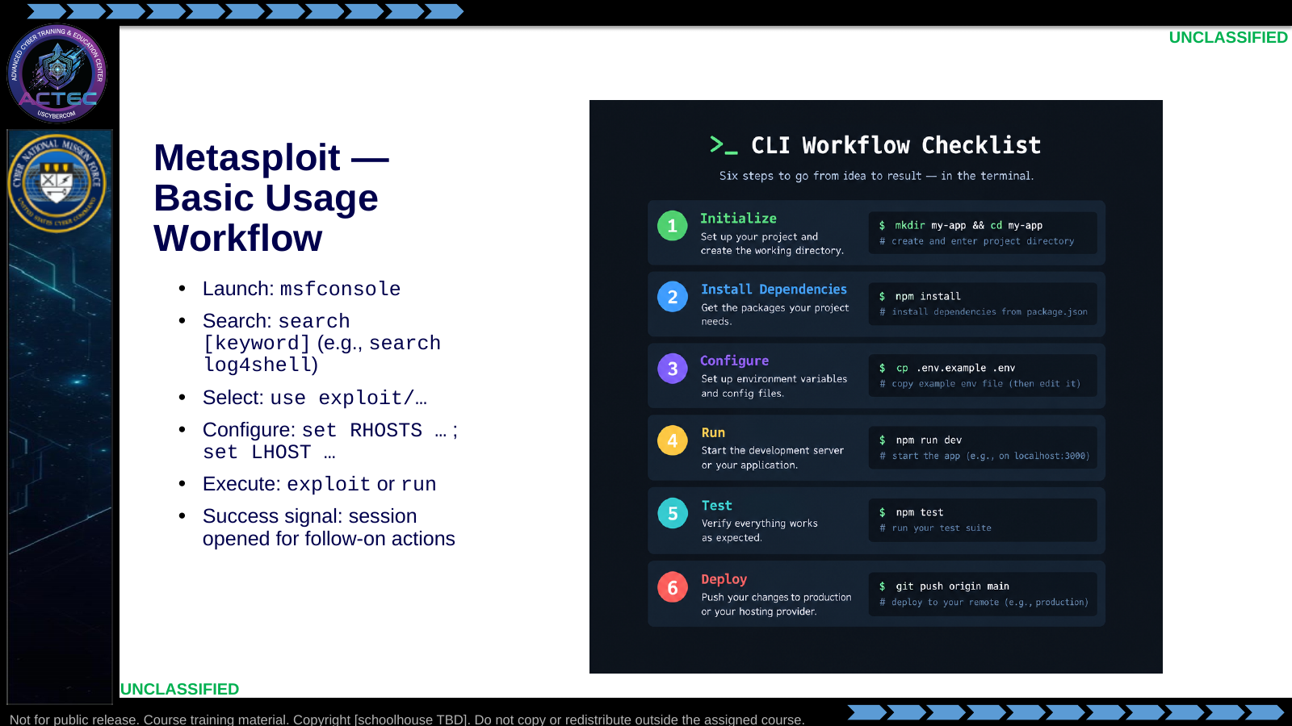  Slide 30: Metasploit — Basic Usage Workflow  Duration: 2 min | Say: - "Six verbs: launch, search, use, set, exploit, verify session."  - "Search before use."  - "Set both remote and callback addresses deliberately."  - "Read errors—most failures are options, not 'MSF is broken.'"  Show: - Walk the checklist without rushing.  Do: - Students write the six steps in order from memory; spot-check two notebooks.  Ask (Q): What is the operational takeaway from this row?  Expected Response (A): Facilitation. Restate the Say/Do in operator terms. Do not invent a new teaching point.
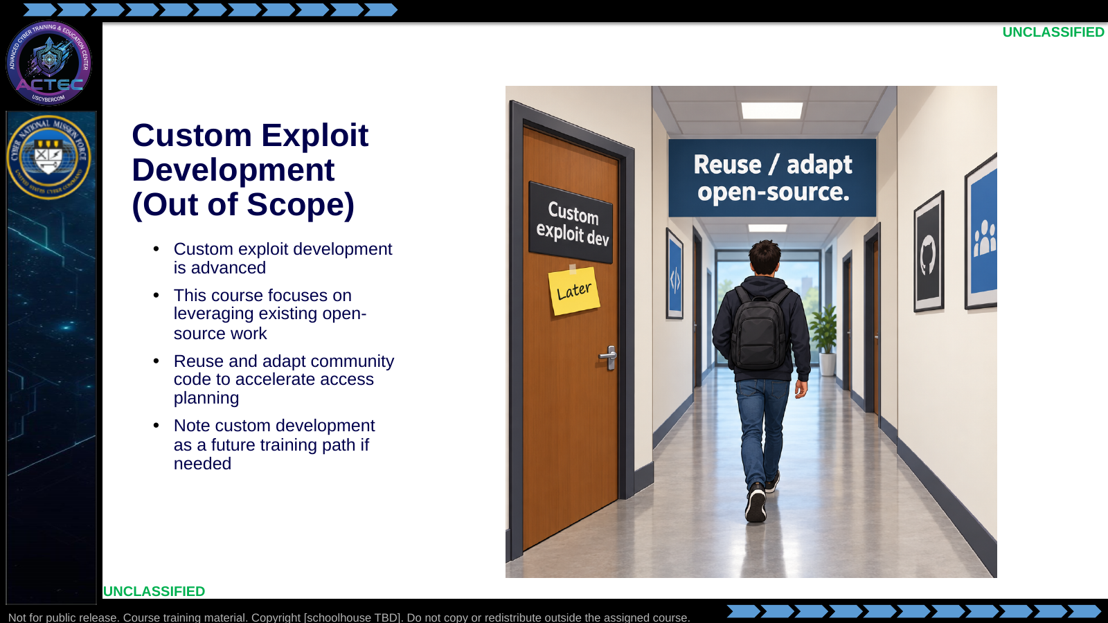  Slide 31: Custom Exploit Development (Out of Scope)  Duration: 2 min | Say: - "We are not writing 0-days in this block."  - "Master navigation, vetting, and adaptation first."  - "Custom development is a different skill pipeline."  - "If a public path does not exist, escalate that finding—do not invent unsafe code under time pressure."  Show: - Point at the closed door vs main hallway.  Do: - Ask for a thumbs-up that scope is clear before continuing.  Ask (Q): What is the operational takeaway from this row?  Expected Response (A): Facilitation. Restate the Say/Do in operator terms. Do not invent a new teaching point.
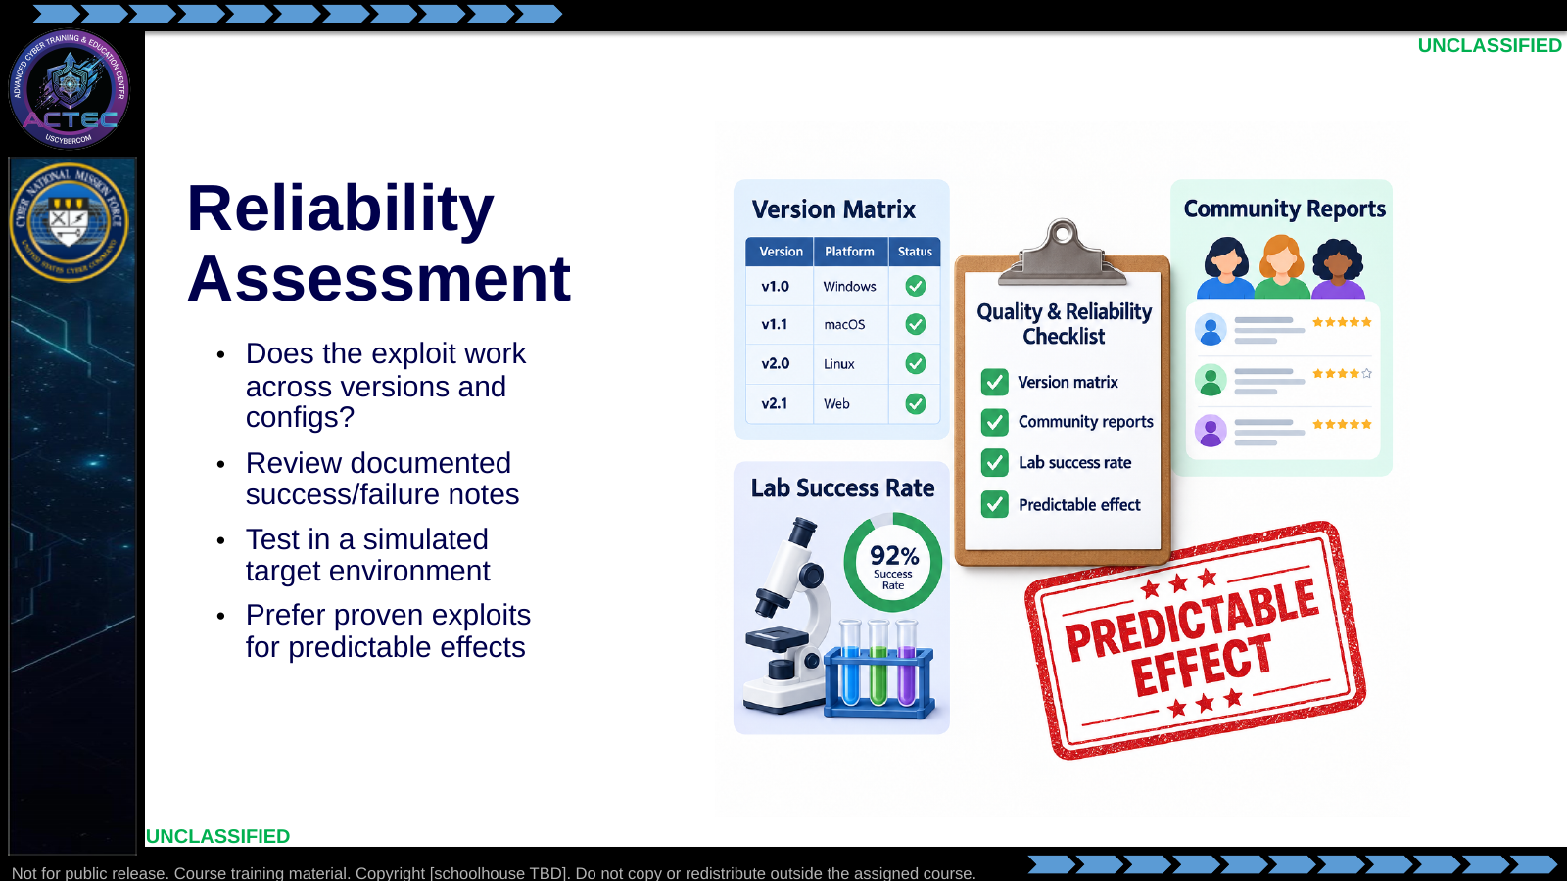  Slide 32: Reliability Assessment  Duration: 2 min | Say: - "Reliability is repeatability."  - "One lucky shell is not a plan."  - "Read the docs and issues for known failure cases."  - "Lab rate informs live confidence."  Show: - Tick the checklist.  Do: - Ask what evidence would convince them an exploit is reliable enough for their COA.  Ask (Q): What is the operational takeaway from this row?  Expected Response (A): Facilitation. Restate the Say/Do in operator terms. Do not invent a new teaching point.
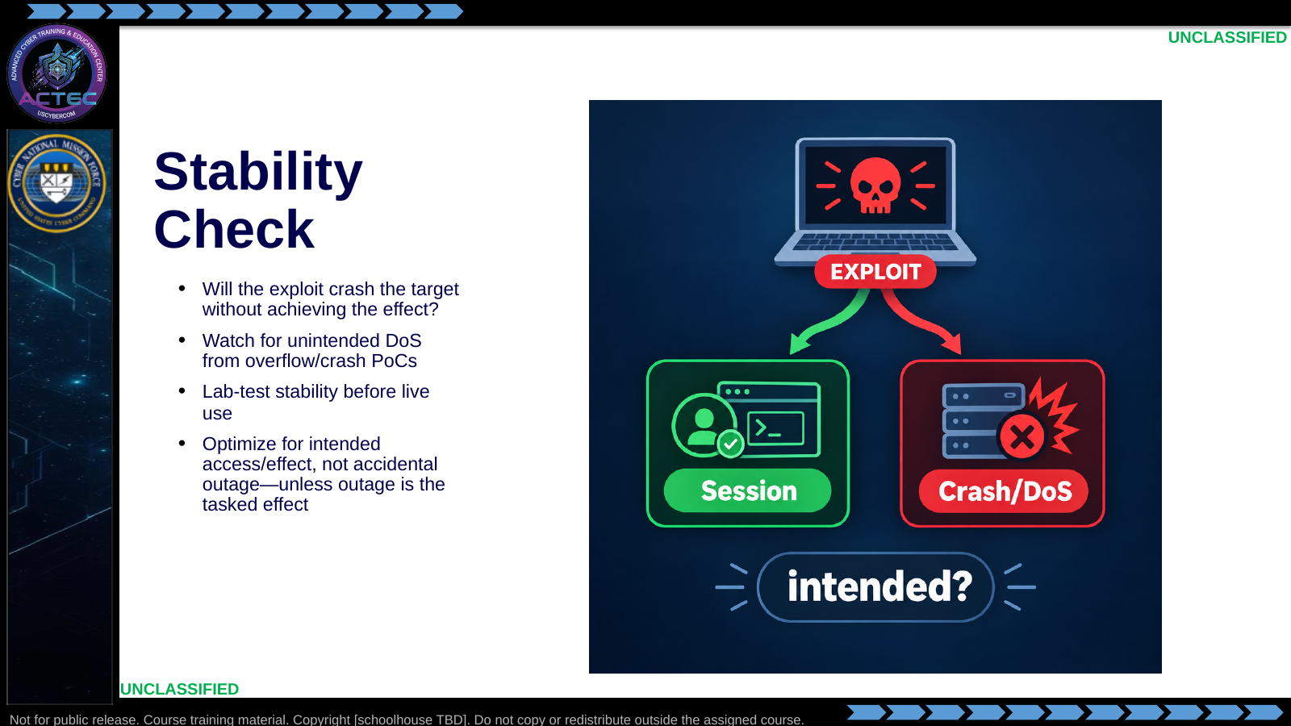  Slide 33: Stability Check  Duration: 2 min | Say: - "Stability is about side effects."  - "A crash can alert defenders and destroy access opportunities."  - "If the tasked effect is disrupt/deny via outage, say so explicitly."  - "Otherwise, treat crash as failure."  Show: - Contrast session vs crash outcomes.  Do: - Pose: "Mission needs a shell for follow-on. Is a crash PoC suitable?" Expect no.  Ask (Q): What is the operational takeaway from this row?  Expected Response (A): Facilitation. Restate the Say/Do in operator terms. Do not invent a new teaching point.
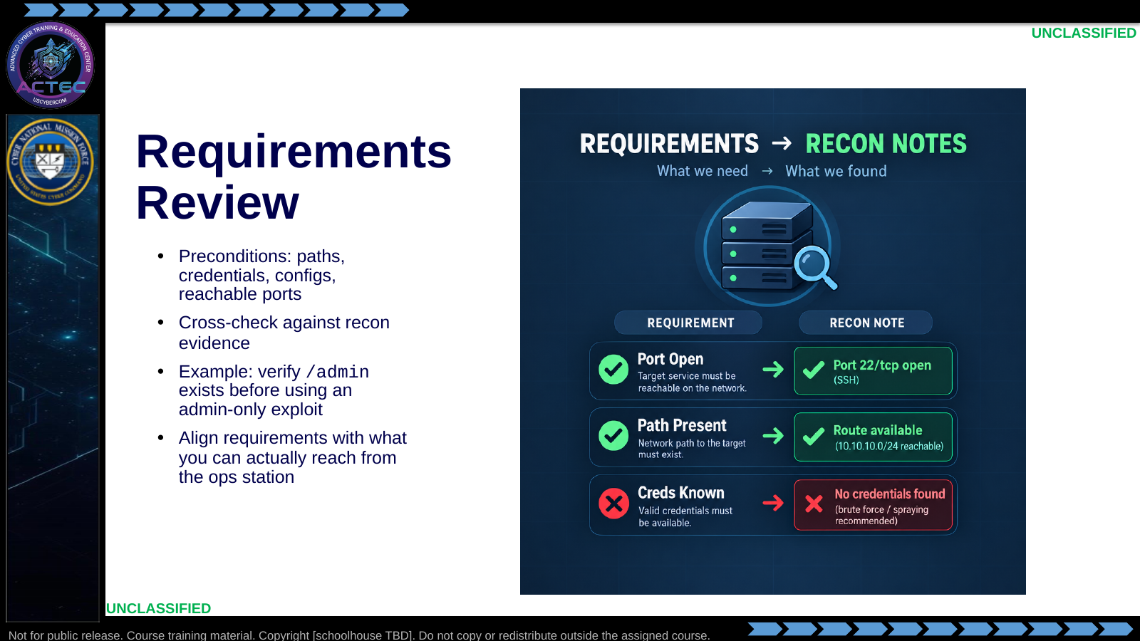  Slide 34: Requirements Review  Duration: 2 min | Say: - "Every exploit has homework."  - "If the module needs a file path, prove the path."  - "If it needs auth, prove creds."  - "Recon either satisfies requirements or the candidate is parked."  Show: - Match each requirement to a recon artifact.  Do: - Give a fake module requiring SMB + guest access; ask what enum proves guest.  Ask (Q): What is the operational takeaway from this row?  Expected Response (A): Facilitation. Restate the Say/Do in operator terms. Do not invent a new teaching point.
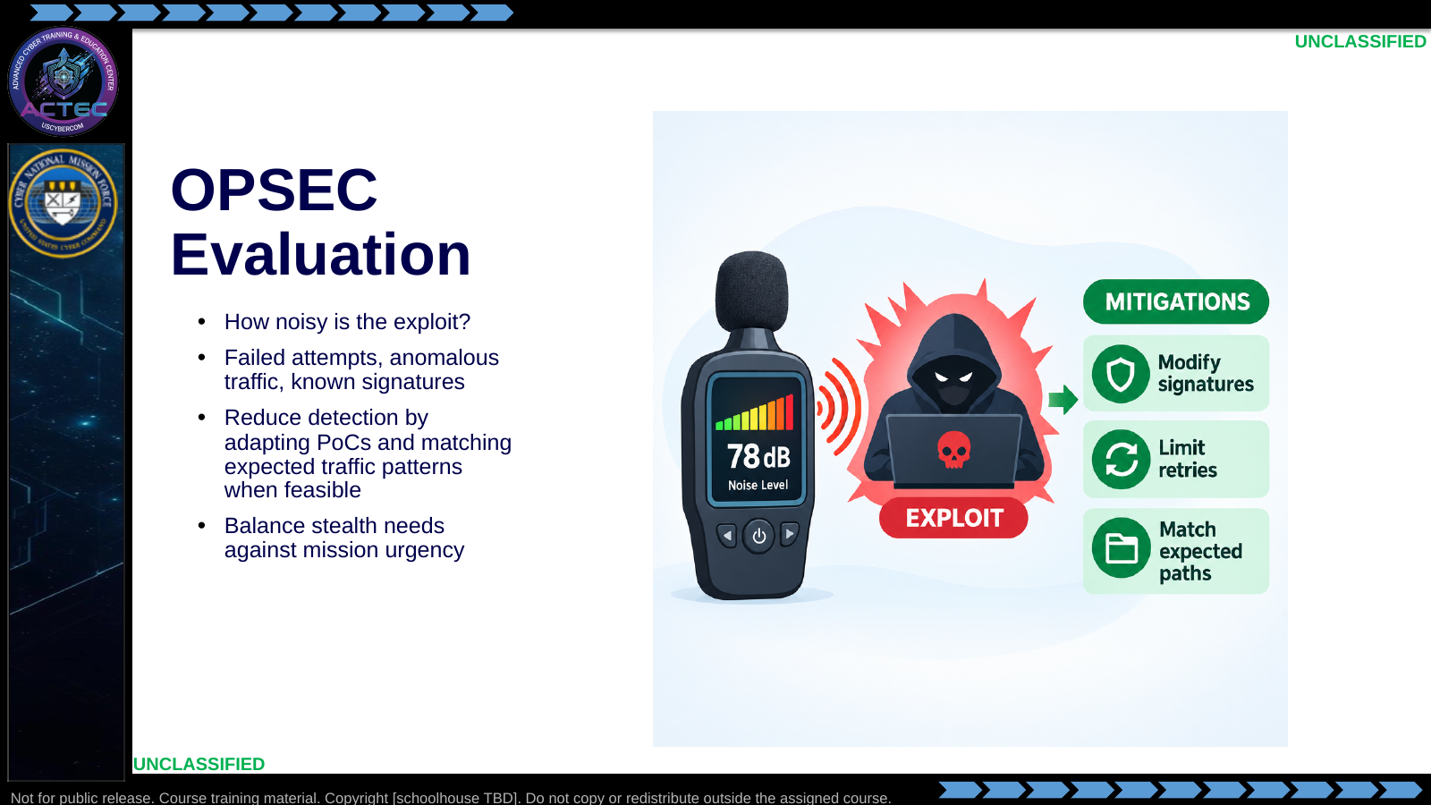  Slide 35: OPSEC Evaluation  Duration: 2 min | Say: - "OPSEC is detectability under adversary eyes."  - "Default public exploits are loud."  - "Retries and wrong payloads create logs."  - "When stealth matters, modify and rehearse; when speed matters, accept noise consciously."  Show: - Walk noise meter and mitigations.  Do: - Ask which upcoming lab values learning speed over stealth (expect early HTB skill labs).  Ask (Q): What is the operational takeaway from this row?  Expected Response (A): Facilitation. Restate the Say/Do in operator terms. Do not invent a new teaching point.
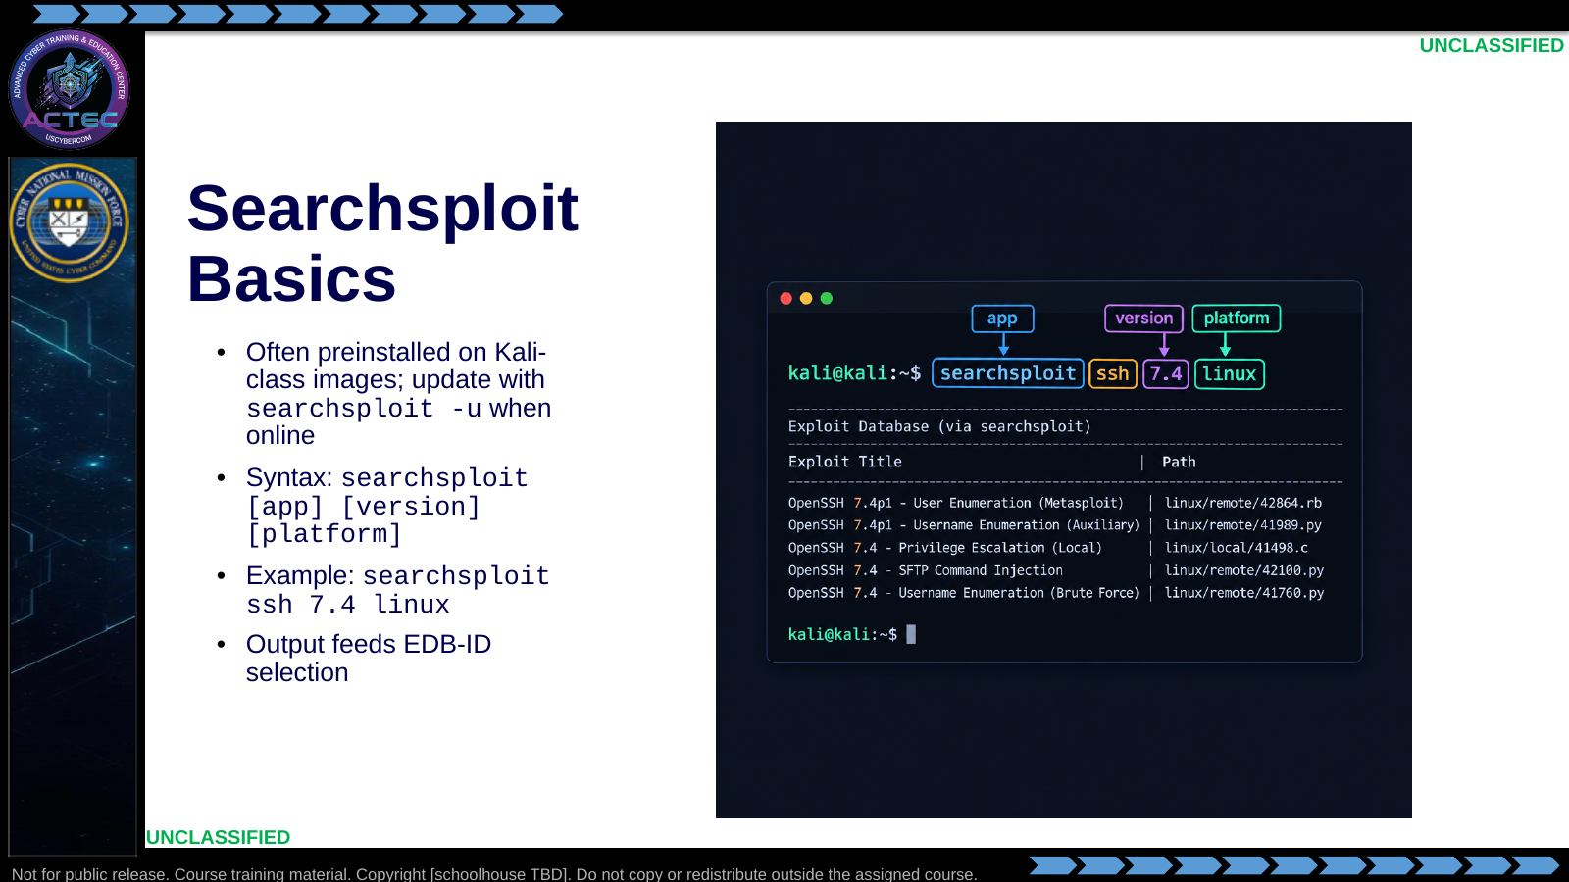  Slide 36: Searchsploit Basics  Duration: 2 min | Say: - "This is the detailed Searchsploit workflow; earlier vulnerability research established the evidence that supplies its query terms."  - "Basics you will type repeatedly."  - "Update when you can; search when you must."  - "Add platform to cut noise."  - "Copy the EDB-ID—you need it for examine/mirror commands."  Show: - Annotate each syntax token.  Do: - Students craft one Searchsploit line from their Nmap service.  Ask (Q): What is the operational takeaway from this row?  Expected Response (A): Facilitation. Restate the Say/Do in operator terms. Do not invent a new teaching point.
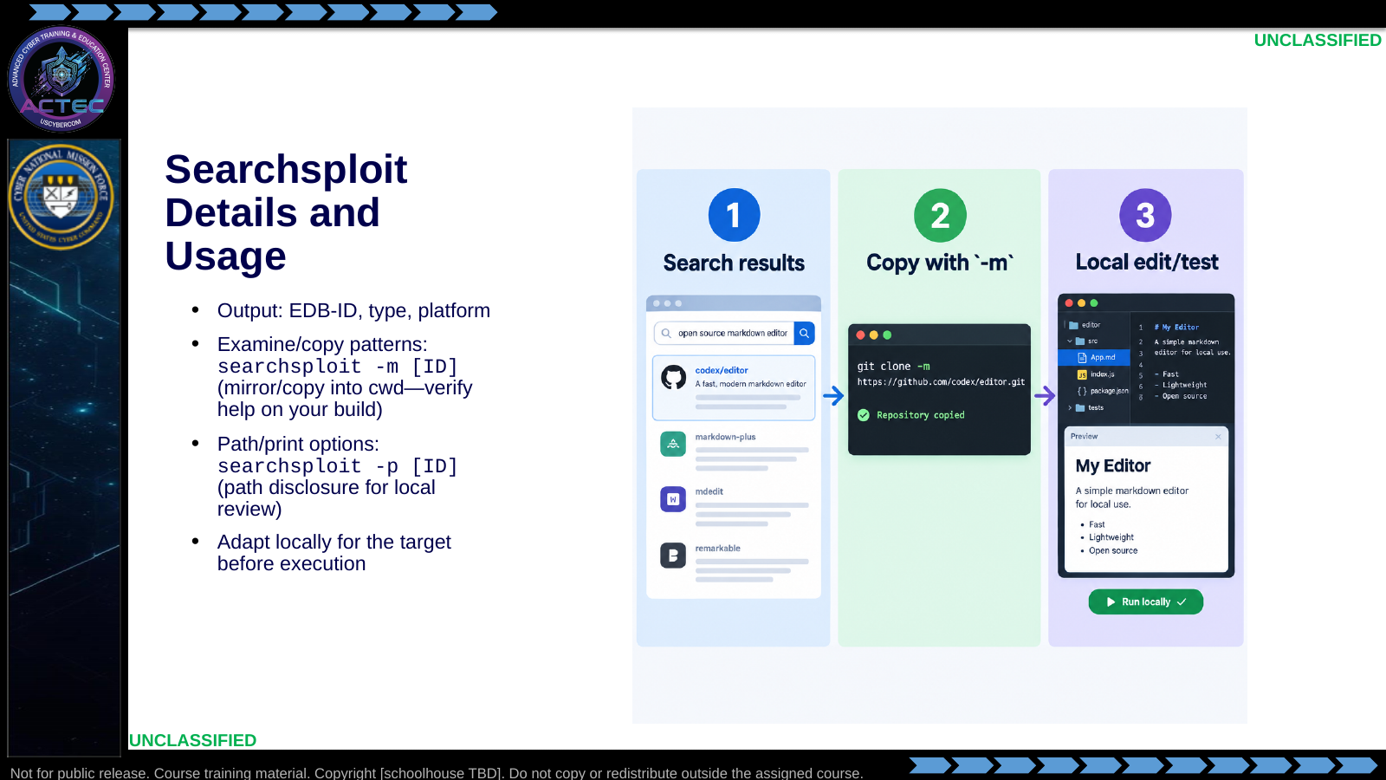  Slide 37: Searchsploit Details and Usage  Duration: 2 min | Say: - "Reading beats running."  - "Mirror the exploit into your working directory."  - "Open it; find the variables that must change."  - "Flags can vary slightly by Searchsploit version—check --help once per image."  Show: - Walk search → copy → edit.  Do: - In lab: require a pre-execution head/less of the script before any run.  Ask (Q): What is the operational takeaway from this row?  Expected Response (A): Facilitation. Restate the Say/Do in operator terms. Do not invent a new teaching point.
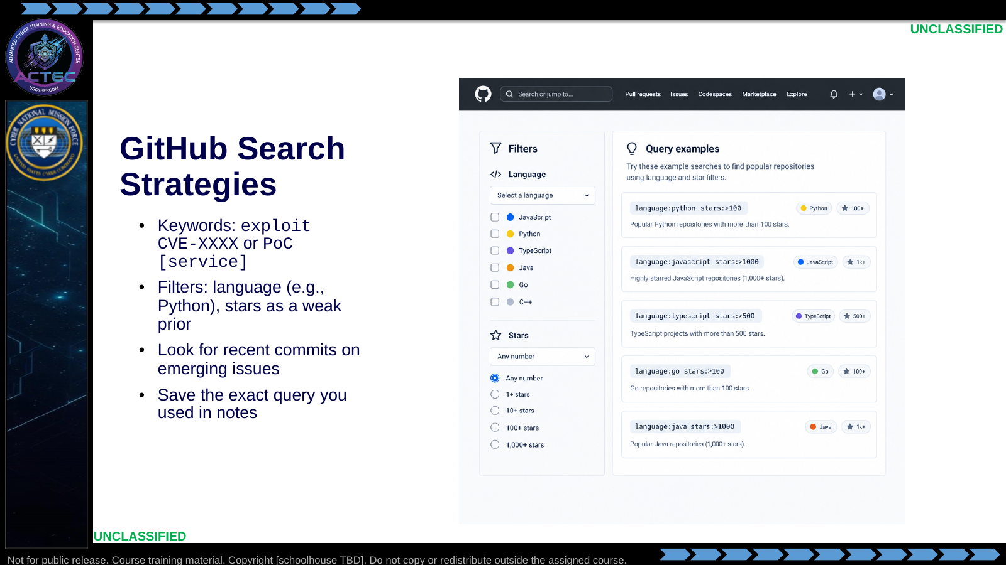  Slide 38: GitHub Search Strategies  Duration: 2 min | Say: - "Search like an analyst."  - "CVE ID queries are precise; service PoC queries are broader."  - "Language filters help when you must maintain the code."  - "Record the query for reproducibility."  Show: - Show example queries.  Do: - Pair students: one writes a CVE query, one writes a service PoC query.  Ask (Q): What is the operational takeaway from this row?  Expected Response (A): Facilitation. Restate the Say/Do in operator terms. Do not invent a new teaching point.
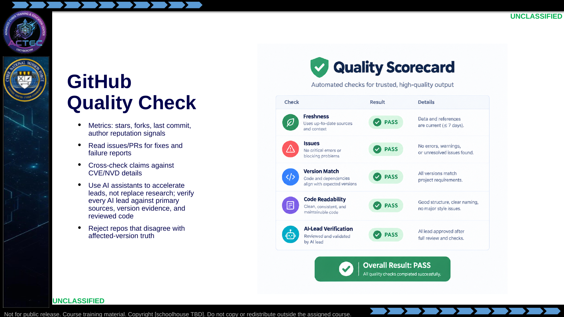  Slide 39: GitHub Quality Check  Duration: 2 min | Say: - "Quality check is mandatory."  - "Dead repos with bold README claims are common."  - "Issues often tell you it only works on one build."  - "SI can accelerate searches and summarize leads, but it is not evidence."  - "Verify every SI-sourced lead against primary sources, observed version evidence, and the code you reviewed."  - "If NVD says not vulnerable, the README does not override reality."  Show: - Walk the scorecard.  Do: - Show a hypothetical README claiming universal RCE; ask what they verify first.  Ask (Q): What is the operational takeaway from this row?  Expected Response (A): Facilitation. Restate the Say/Do in operator terms. Do not invent a new teaching point.
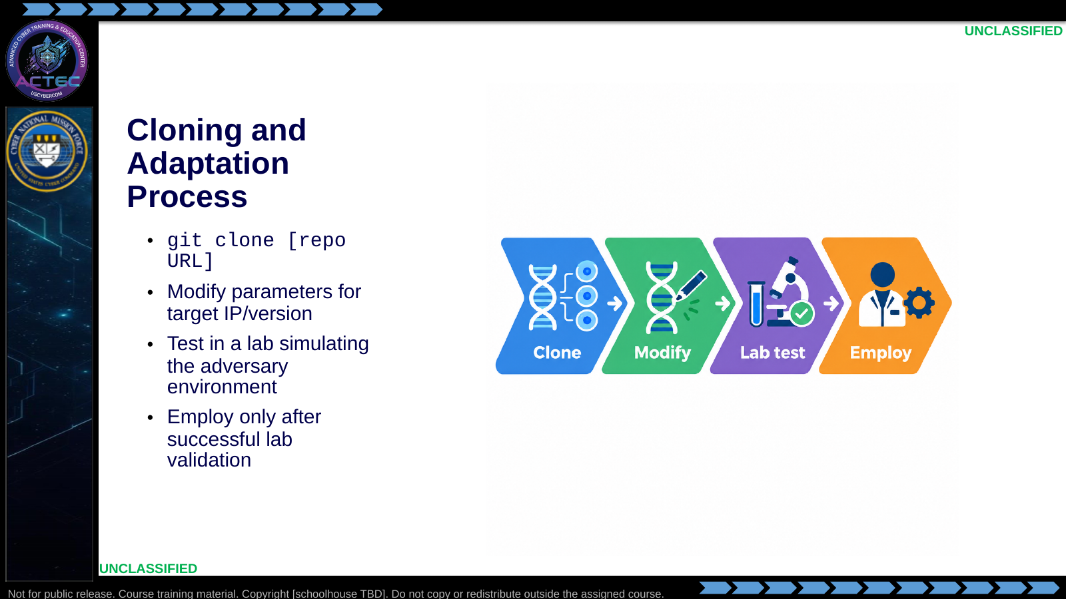  Slide 40: Cloning and Adaptation Process  Duration: 2 min | Say: - "Clone is the start, not the finish."  - "Edit for your address plan and version."  - "Lab test is the go/no-go gate."  - "No silent live first-tries with untrusted code."  Show: - Walk the four chevrons.  Do: - Ask what single parameter mistake most often breaks reverse shells (LHOST/callback).  - Ask: "Name three things you would read in a cloned PoC before any execution." Drive toward: target OS assumptions, required ports, and whether recon actually shows that service/version.  Ask (Q): Name three things you would read in a cloned PoC before any execution.  Expected Response (A): target OS assumptions, required ports, and whether recon actually shows that service/version
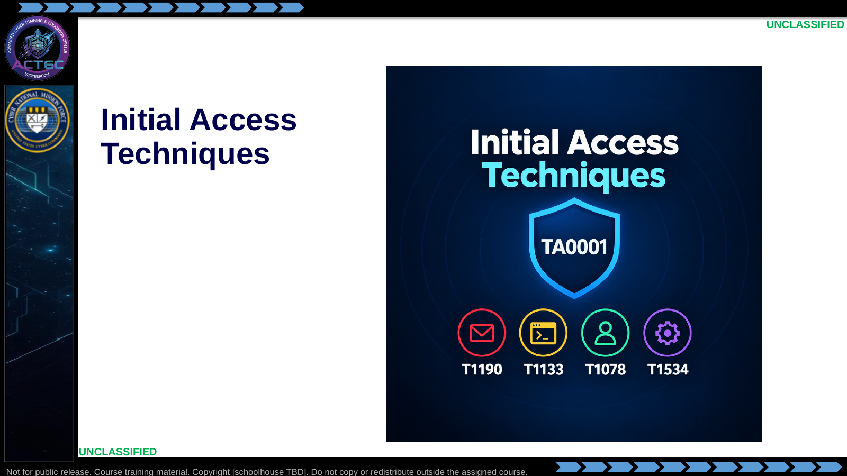  Slide 41: Initial Access Techniques  Duration: 2 min | Say: - "Research becomes operational only when it maps to an access technique that the evidence supports."  Show: - Hold on the TA0001 visual, then advance.  Do: - Have students keep one candidate in mind to map during this block.  Ask (Q): What is the operational takeaway from this row?  Expected Response (A): Facilitation. Restate the Say/Do in operator terms. Do not invent a new teaching point.
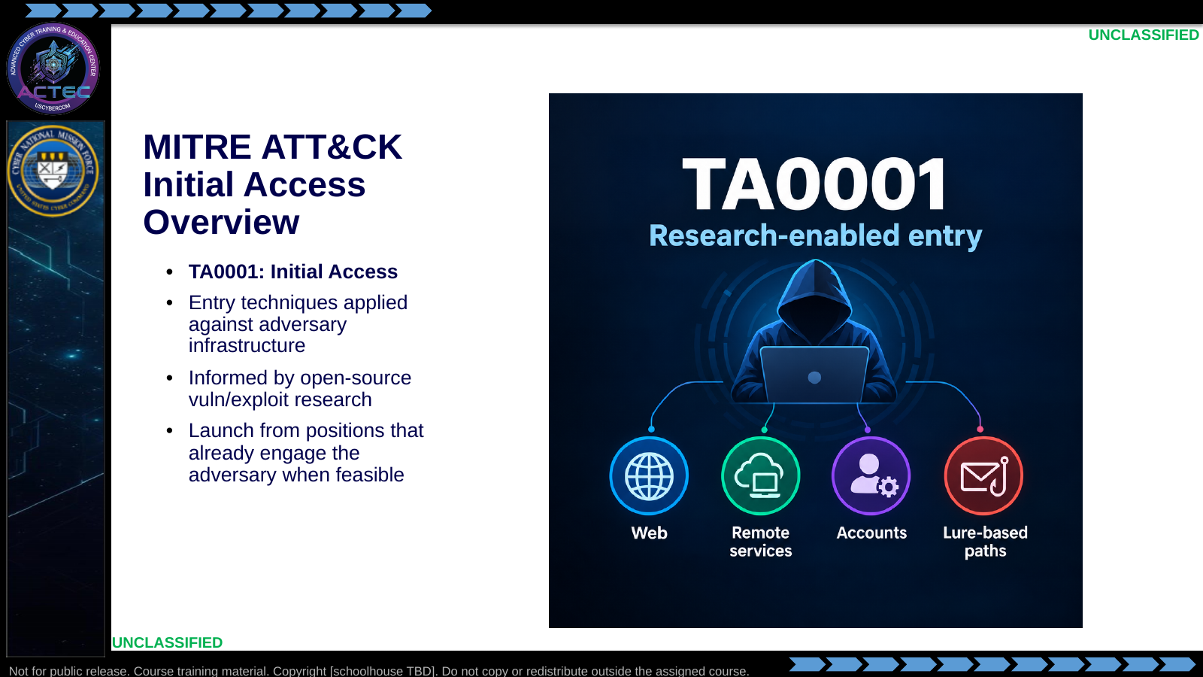  Slide 42: MITRE ATT&CK Initial Access Overview  Duration: 2 min | Say: - "Initial Access is the tactic."  - "Techniques are how you enter."  - "Your research narrows which technique is honest."  - "Prefer paths that match how you already reach the target."  Show: - Sweep the technique icons.  Do: - Ask for a one-sentence definition of Initial Access in operator language.  Ask (Q): What is the operational takeaway from this row?  Expected Response (A): Facilitation. Restate the Say/Do in operator terms. Do not invent a new teaching point.
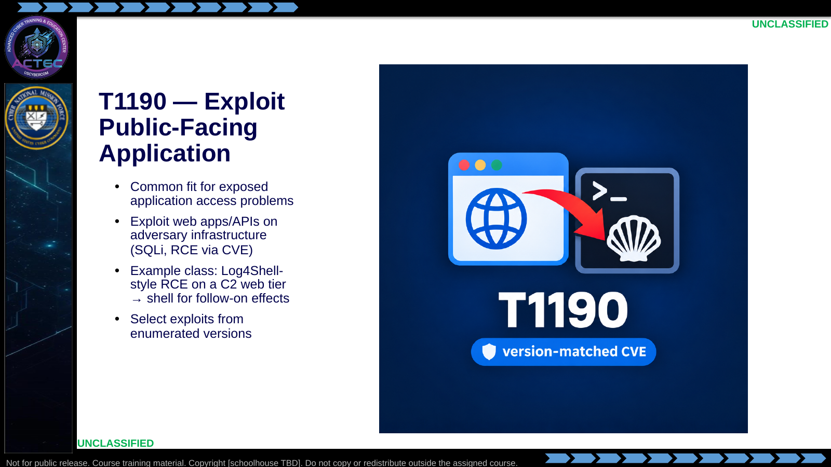  Slide 43: T1190 — Exploit Public-Facing Application  Duration: 2 min | Say: - "T1190 is your default when a public app is exposed."  - "SQLi and RCE are common shapes—later access practice will use several."  - "Version-matched CVEs make this technique concrete."  - "Foothold is the start; effects come after."  Show: - Trace public app → exploit → shell.  Do: - Ask which student ports from recon look T1190-shaped (80/443/app ports).  Ask (Q): What is the operational takeaway from this row?  Expected Response (A): Facilitation. Restate the Say/Do in operator terms. Do not invent a new teaching point.
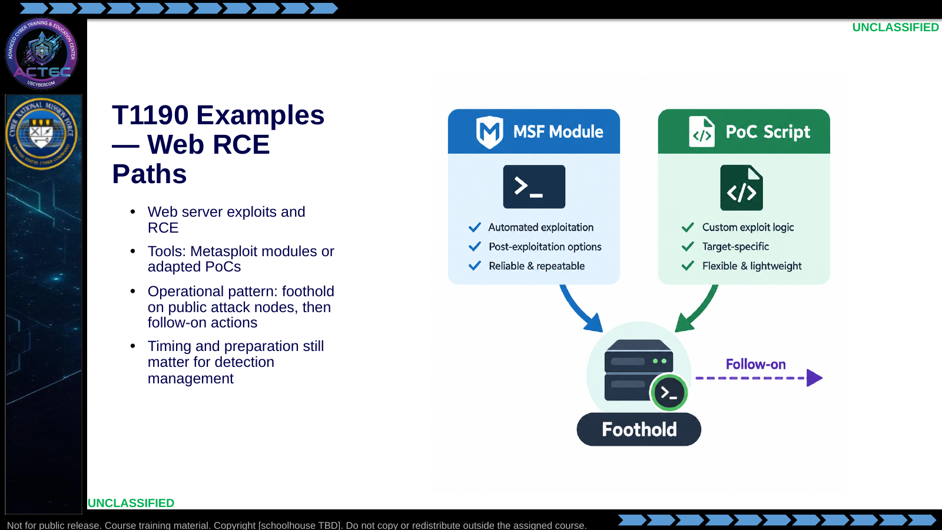  Slide 44: T1190 Examples — Web RCE Paths  Duration: 2 min | Say: - "Same technique, multiple actions."  - "MSF when a good module exists and fits policy/lab rules."  - "PoC when you need transparency or MSF is unavailable."  - "Plan the follow-on before you celebrate the shell."  Show: - Compare the two toolkit cards.  Do: - Tie to Metasploit and to manual Searchsploit judgment.  Ask (Q): What is the operational takeaway from this row?  Expected Response (A): Facilitation. Restate the Say/Do in operator terms. Do not invent a new teaching point.
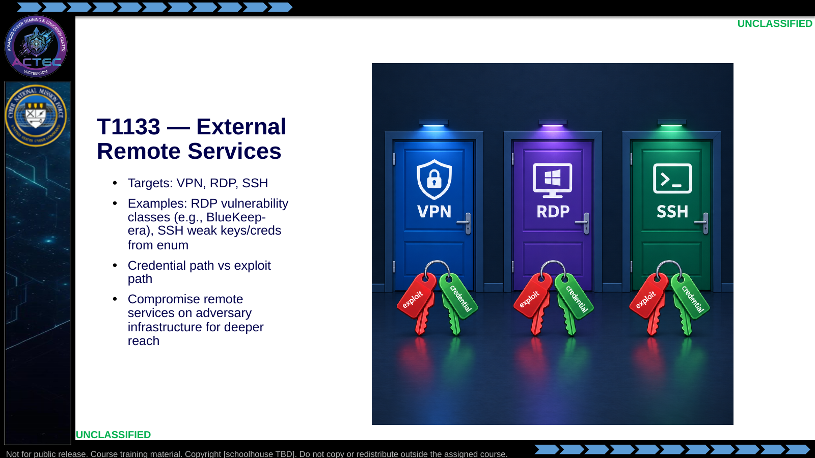  Slide 45: T1133 — External Remote Services  Duration: 2 min | Say: - "T1133 is remote administration surfaces."  - "Sometimes you exploit the service."  - "Sometimes you authenticate with discovered credentials."  - "Enum tells you which door is real and which path is viable."  Show: - Point at exploit vs credential keys on each door.  Do: - Ask: "From Nmap, what evidence pushes you to T1133 over T1190?"  Ask (Q): From Nmap, what evidence pushes you to T1133 over T1190?  Expected Response (A): Facilitation. Use the Say/Do already on this row; do not force a single keyed answer.
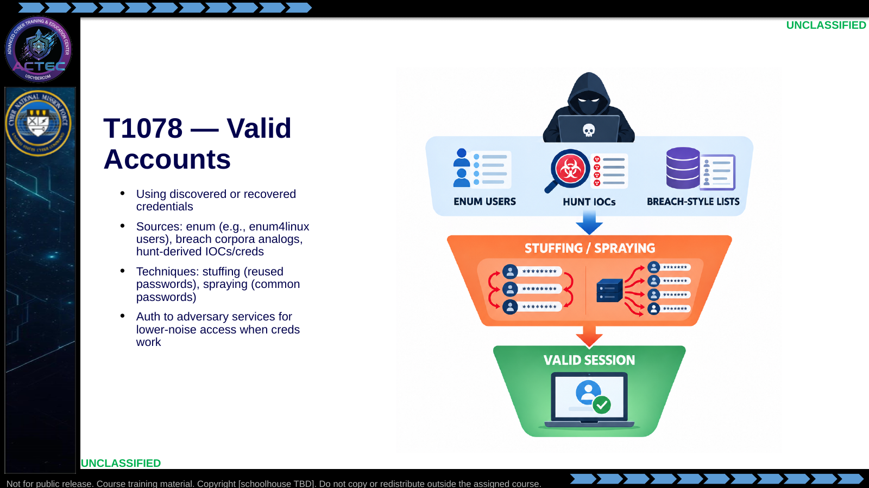  Slide 46: T1078 — Valid Accounts  Duration: 2 min | Say: - "Valid accounts skip a lot of exploit noise."  - "Build the user list from enum and hunt evidence."  - "Stuffing and spraying are different tempos—know which you are doing."  - "Validate carefully; lockouts are an OPSEC and stability issue."  Show: - Walk the funnel.  Do: - Ask where they already saw username discovery during recon.  Ask (Q): What is the operational takeaway from this row?  Expected Response (A): Facilitation. Restate the Say/Do in operator terms. Do not invent a new teaching point.
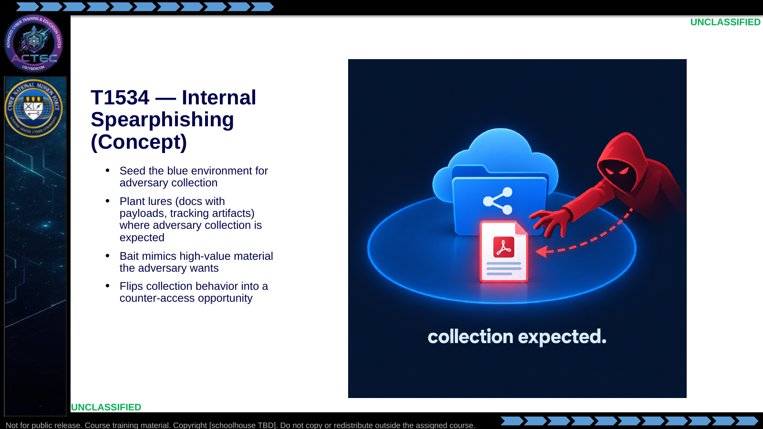  Slide 47: T1534 — Internal Spearphishing (Concept)  Duration: 2 min | Say: - "T1534 here is the reverse lure idea."  - "You place bait on terrain the adversary already steals from."  - "The lure must look like something worth taking."  - "This is planning-heavy and environment-dependent—not every mission uses it."  Show: - Trace adversary collection to the lure.  Do: - Ask what blue artifact an adversary might routinely collect in a hunt scenario.  Ask (Q): What is the operational takeaway from this row?  Expected Response (A): Facilitation. Restate the Say/Do in operator terms. Do not invent a new teaching point.
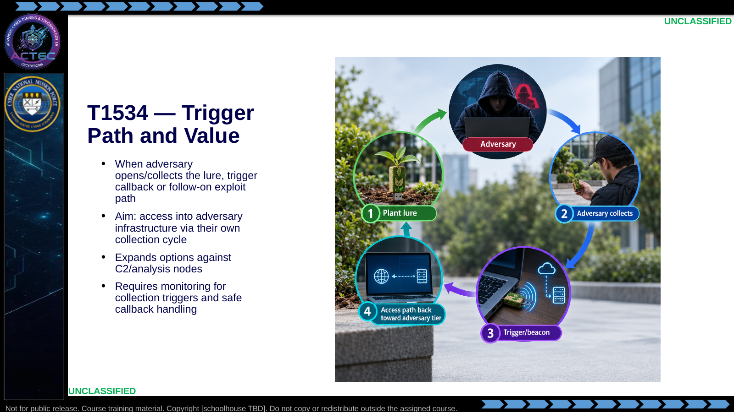  Slide 48: T1534 — Trigger Path and Value  Duration: 2 min | Say: - "Value appears only if collection actually happens."  - "You need a monitor plan and a callback plan."  - "This is not 'spray phishing the internet'—it is terrain the adversary already touches."  - "Treat it as advanced sequencing relative to straight T1190."  Show: - Step through plant → collect → trigger → access.  Do: - Contrast speed: T1190 direct exploit vs T1534 waiting on adversary behavior.  Ask (Q): What is the operational takeaway from this row?  Expected Response (A): Facilitation. Restate the Say/Do in operator terms. Do not invent a new teaching point.
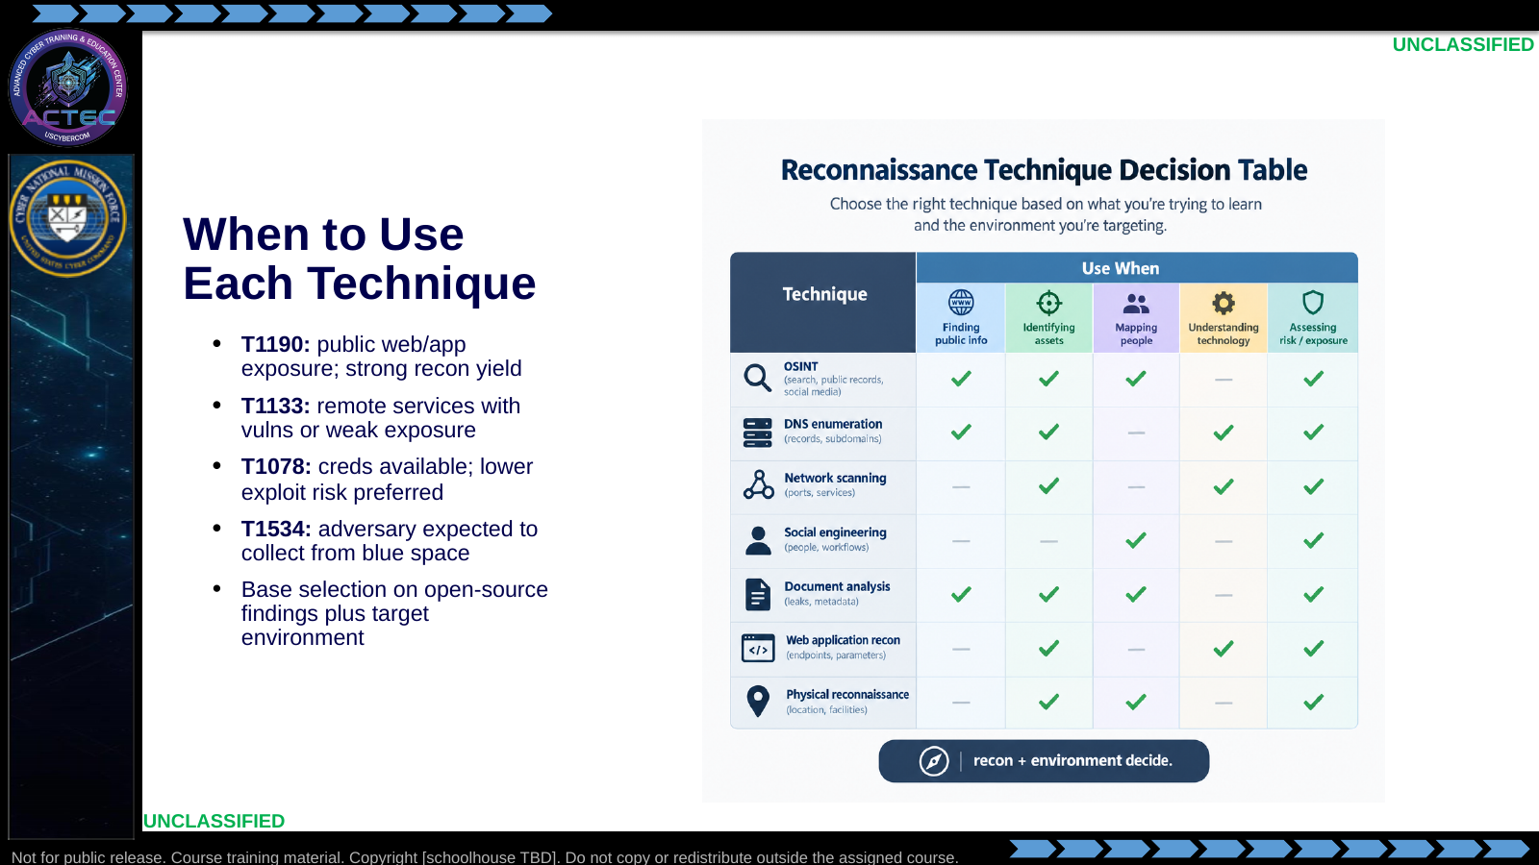  Slide 49: When to Use Each Technique  Duration: 2 min | Say: - "Selection is conditional."  - "Public app evidence points T1190."  - "Admin services point T1133."  - "Creds point T1078."  - "Expected collection points T1534."  - "Open-source research informs feasibility inside each row."  Show: - Walk the table row by row.  Do: - Give one scenario per row; students call the technique ID.  Ask (Q): What is the operational takeaway from this row?  Expected Response (A): Facilitation. Restate the Say/Do in operator terms. Do not invent a new teaching point.
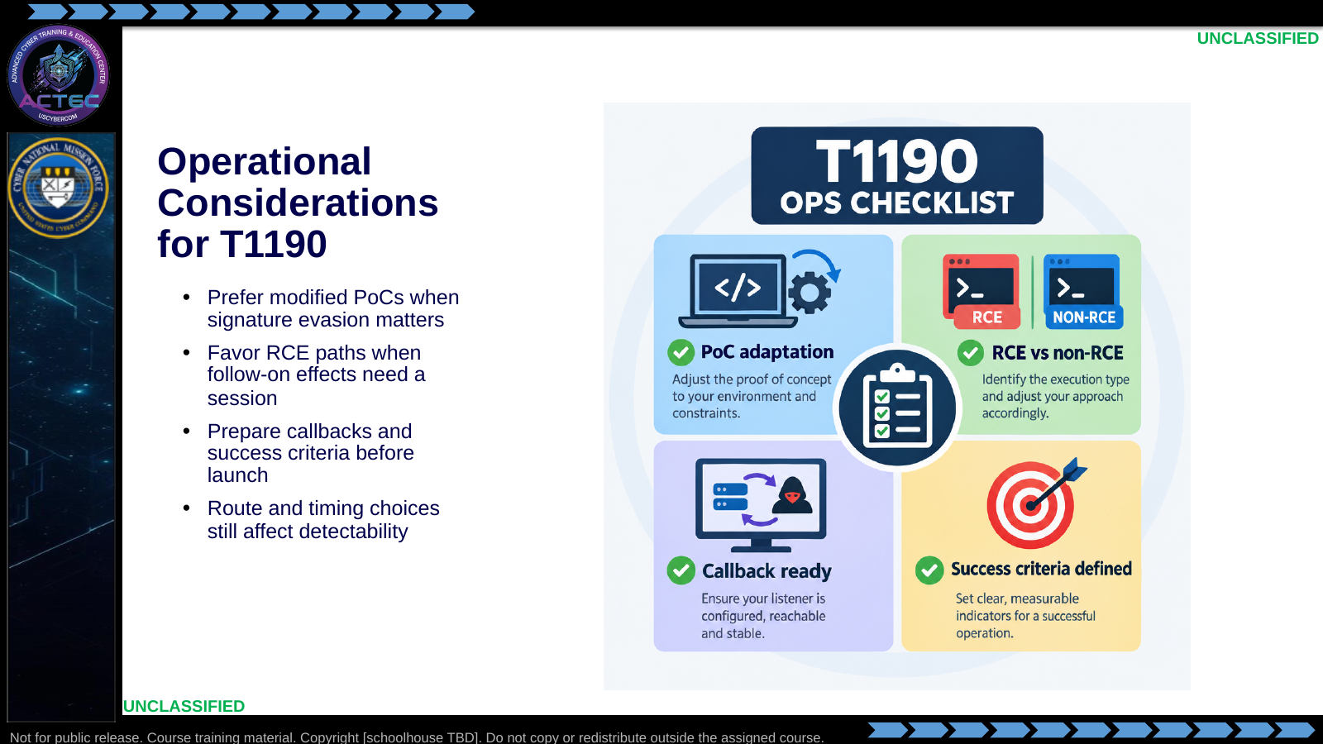  Slide 50: Operational Considerations for T1190  Duration: 2 min | Say: - "T1190 execution still has operator choices."  - "Adaptation can reduce trivial signature hits."  - "RCE is the usual path to meaningful follow-on."  - "If you cannot state success criteria, you are not ready to launch."  Show: - Tick the checklist.  Do: - Students write one success criterion for a web RCE attempt.  Ask (Q): What is the operational takeaway from this row?  Expected Response (A): Facilitation. Restate the Say/Do in operator terms. Do not invent a new teaching point.
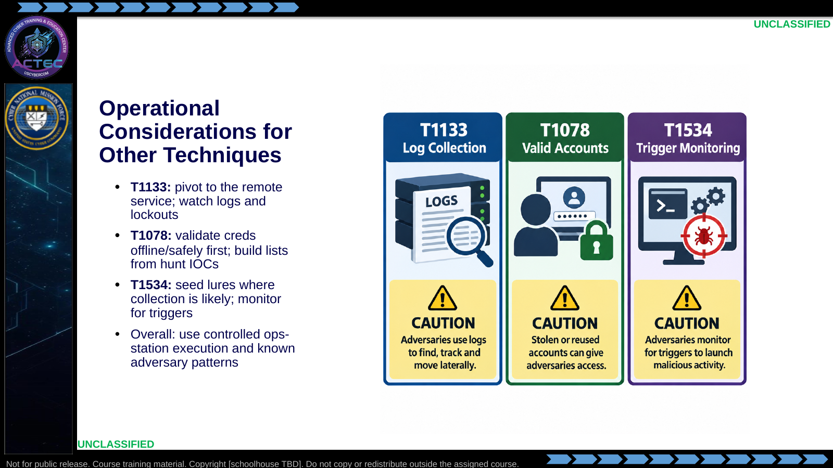  Slide 51: Operational Considerations for Other Techniques  Duration: 2 min | Say: - "Each technique fails differently."  - "Remote services produce authentication and session logs."  - "Credential attacks produce lockouts and alerts."  - "Lures produce nothing until collection happens—patience and monitoring."  Show: - Point to each caution.  Do: - Ask which failure mode is hardest to recover from; discuss briefly.  Ask (Q): What is the operational takeaway from this row?  Expected Response (A): Facilitation. Restate the Say/Do in operator terms. Do not invent a new teaching point.
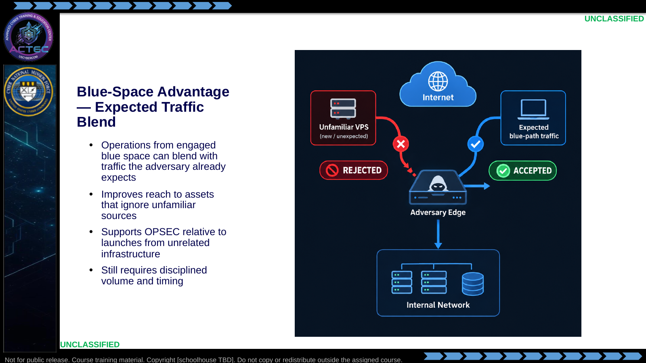  Slide 52: Blue-Space Advantage — Expected Traffic Blend  Duration: 2 min | Say: - "Where you launch from changes outcomes."  - "Adversaries often expect and allow certain blue-origin patterns."  - "Unfamiliar sources get blocked or watched."  - "Blending is an advantage—not a free pass to be loud."  Show: - Compare rejected vs accepted paths.  Do: - Ask for an example of traffic an adversary C2 might already expect from victims.  Ask (Q): What is the operational takeaway from this row?  Expected Response (A): Facilitation. Restate the Say/Do in operator terms. Do not invent a new teaching point.
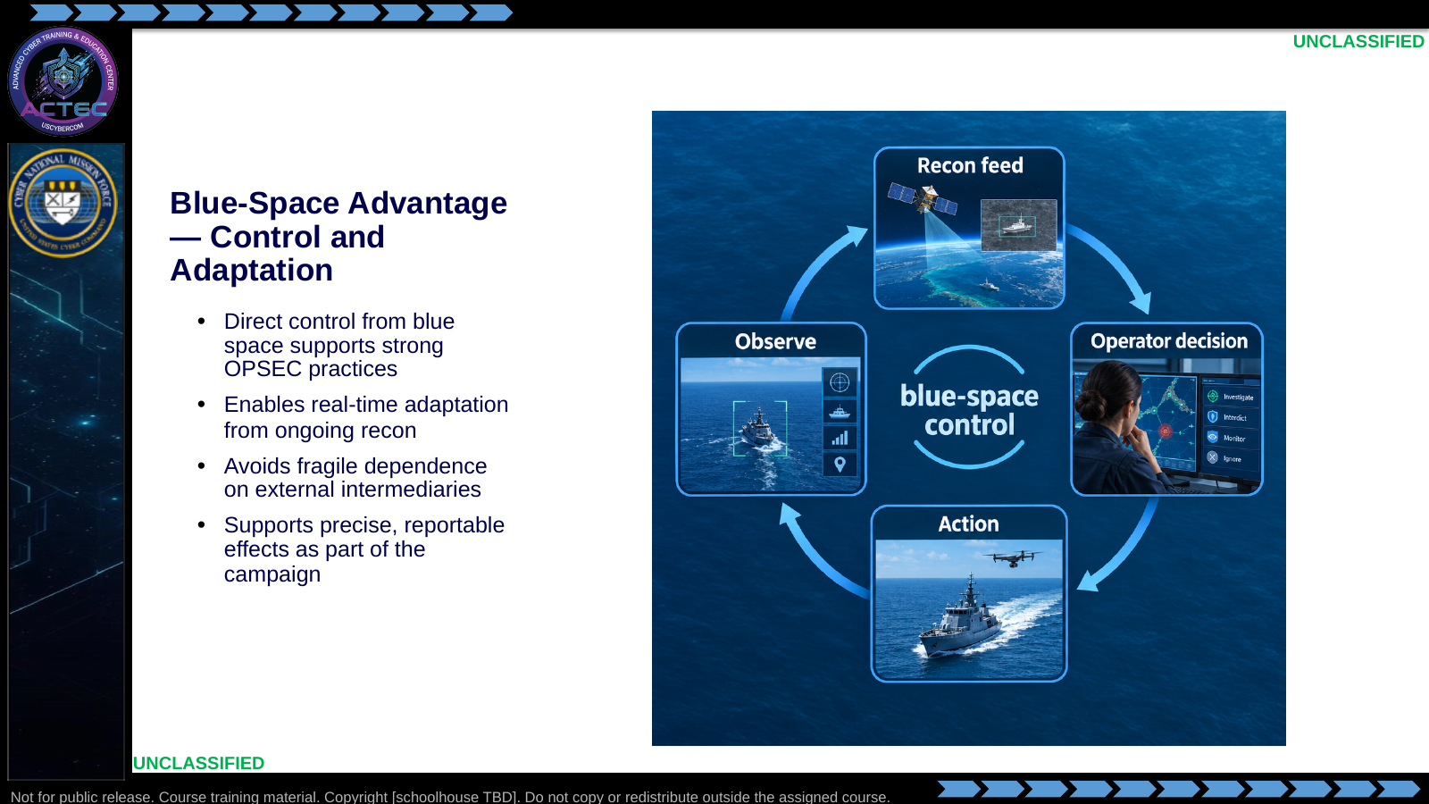  Slide 53: Blue-Space Advantage — Control and Adaptation  Duration: 2 min | Say: - "Control means you can adapt mid-operation."  - "You see recon updates and change COAs."  - "Fewer external dependencies means fewer broken handoffs."  - "Effects stay reportable because you own the execution trail."  Show: - Walk the control loop.  Do: - Ask how lab logging mirrors this control advantage at small scale.  Ask (Q): What is the operational takeaway from this row?  Expected Response (A): Facilitation. Restate the Say/Do in operator terms. Do not invent a new teaching point.
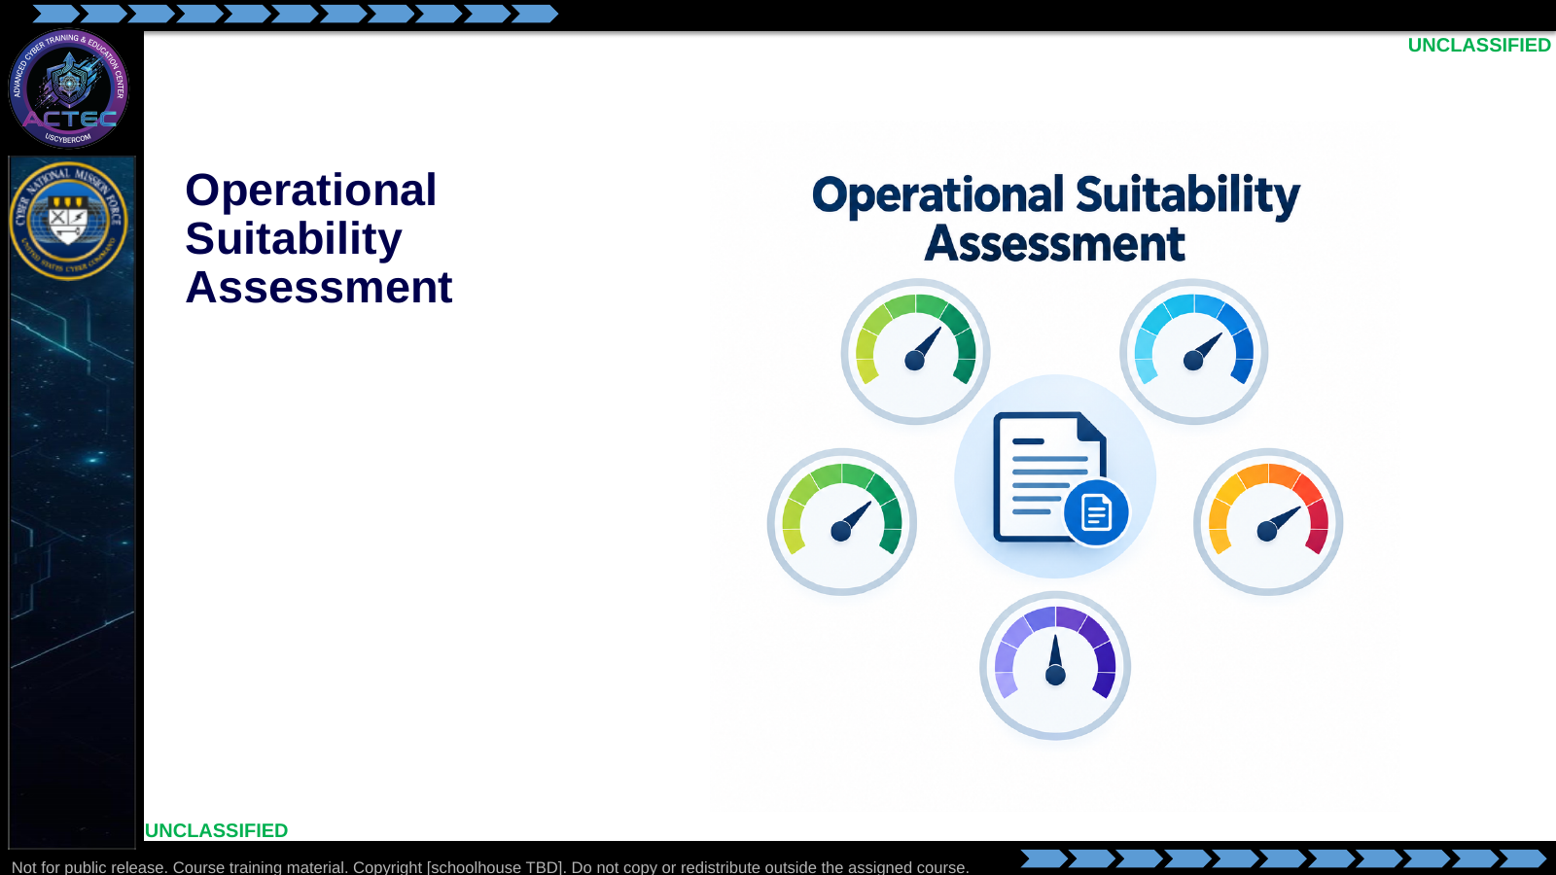  Slide 54: Operational Suitability Assessment  Duration: 2 min | Say: - "Before employment, verify whether a candidate fits the target, task, and expected effect."  Show: - Hold on the suitability gauges, then advance.  Do: - Tell students to use these factors when they justify their lab selection.  Ask (Q): What is the operational takeaway from this row?  Expected Response (A): Facilitation. Restate the Say/Do in operator terms. Do not invent a new teaching point.
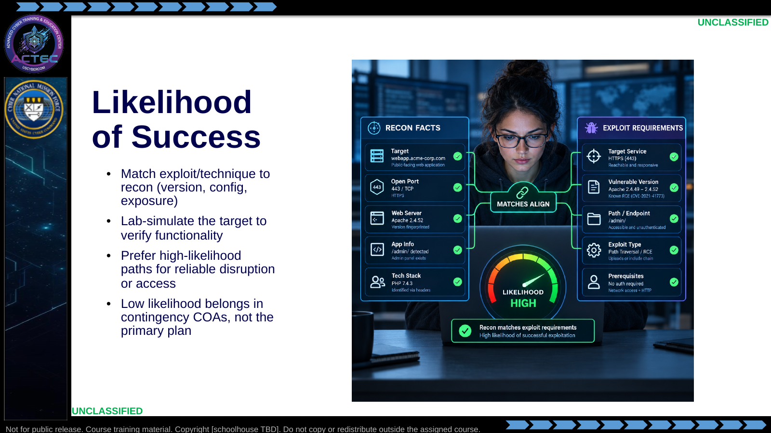  Slide 55: Likelihood of Success  Duration: 2 min | Say: - "Likelihood starts with match quality."  - "Version and config alignment first."  - "Lab proof second."  - "Do not build the primary COA on a long shot."  Show: - Move the dial as matches align.  Do: - Give a mismatched version scenario; students call likelihood low and say why.  Ask (Q): What is the operational takeaway from this row?  Expected Response (A): Facilitation. Restate the Say/Do in operator terms. Do not invent a new teaching point.
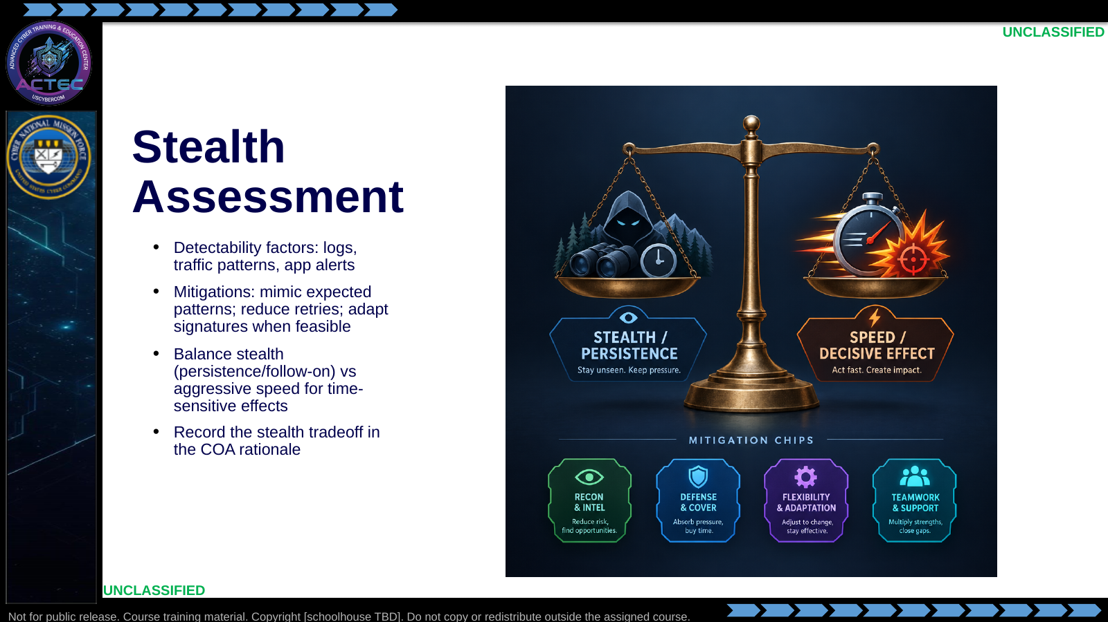  Slide 56: Stealth Assessment  Duration: 2 min | Say: - "Stealth is not always the top priority—but it is always assessed."  - "Name what will log you."  - "Name what you will do to reduce that."  - "If you choose noisy, own it in the plan."  Show: - Tip the scale both ways with example missions.  Do: - Two volunteers: one argues stealth COA, one argues speed COA, same target.  Ask (Q): What is the operational takeaway from this row?  Expected Response (A): Facilitation. Restate the Say/Do in operator terms. Do not invent a new teaching point.
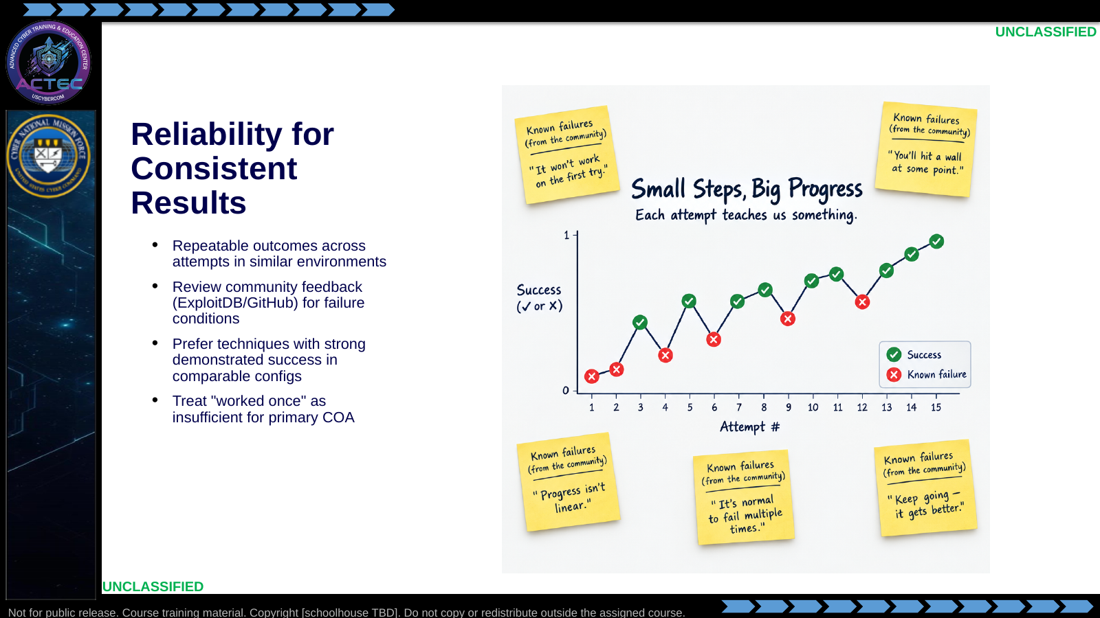  Slide 57: Reliability for Consistent Results  Duration: 2 min | Say: - "Reliability is statistical intuition plus evidence."  - "Community failure notes matter."  - "Comparable configs matter—do not borrow success from a different stack."  - "Primary COAs need boring, repeatable tools."  Show: - Point at repeated successes vs one-off spike.  Do: - Ask what lab evidence would raise confidence after a first success.  Ask (Q): What is the operational takeaway from this row?  Expected Response (A): Facilitation. Restate the Say/Do in operator terms. Do not invent a new teaching point.
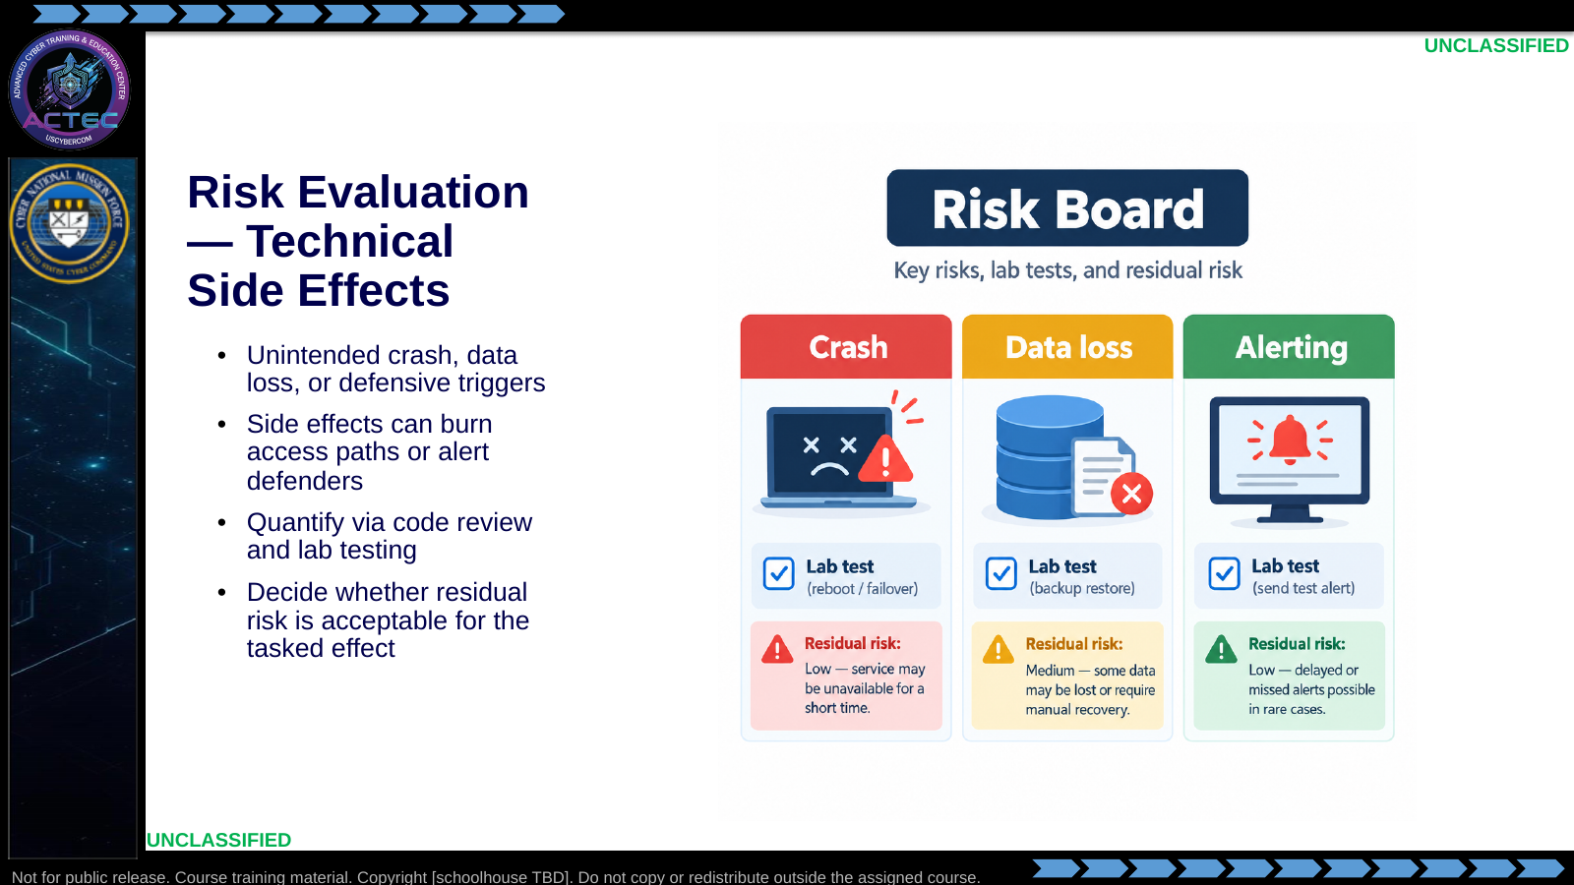  Slide 58: Risk Evaluation — Technical Side Effects  Duration: 2 min | Say: - "Risk starts technical."  - "Crash and alerting are first-order concerns."  - "Lab testing is how you price residual risk."  - "Accept risk only when the tasked effect justifies it."  Show: - Walk the risk board.  Do: - Ask which side effect is worst for a follow-on collection mission (usually alerting/crash).  Ask (Q): What is the operational takeaway from this row?  Expected Response (A): Facilitation. Restate the Say/Do in operator terms. Do not invent a new teaching point.
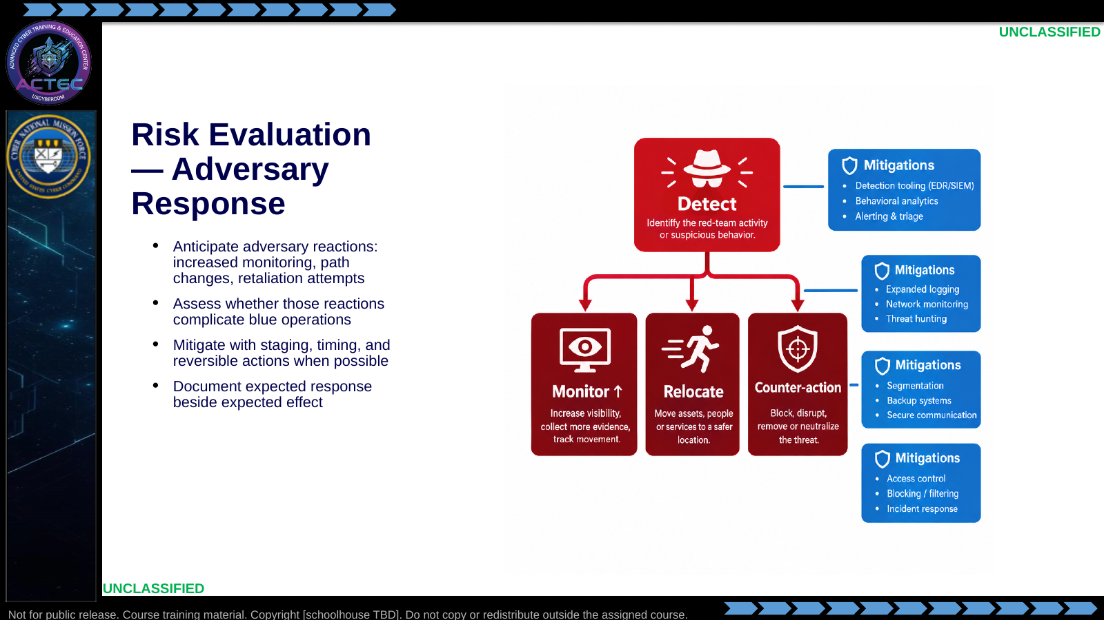  Slide 59: Risk Evaluation — Adversary Response  Duration: 2 min | Say: - "Effects create responses."  - "Ask how the adversary will notice."  - "Ask what they will do next."  - "Put expected response in the plan next to expected effect."  Show: - Walk detect → response branches.  Do: - Students write one expected adversary response for a noisy T1190.  Ask (Q): What is the operational takeaway from this row?  Expected Response (A): Facilitation. Restate the Say/Do in operator terms. Do not invent a new teaching point.
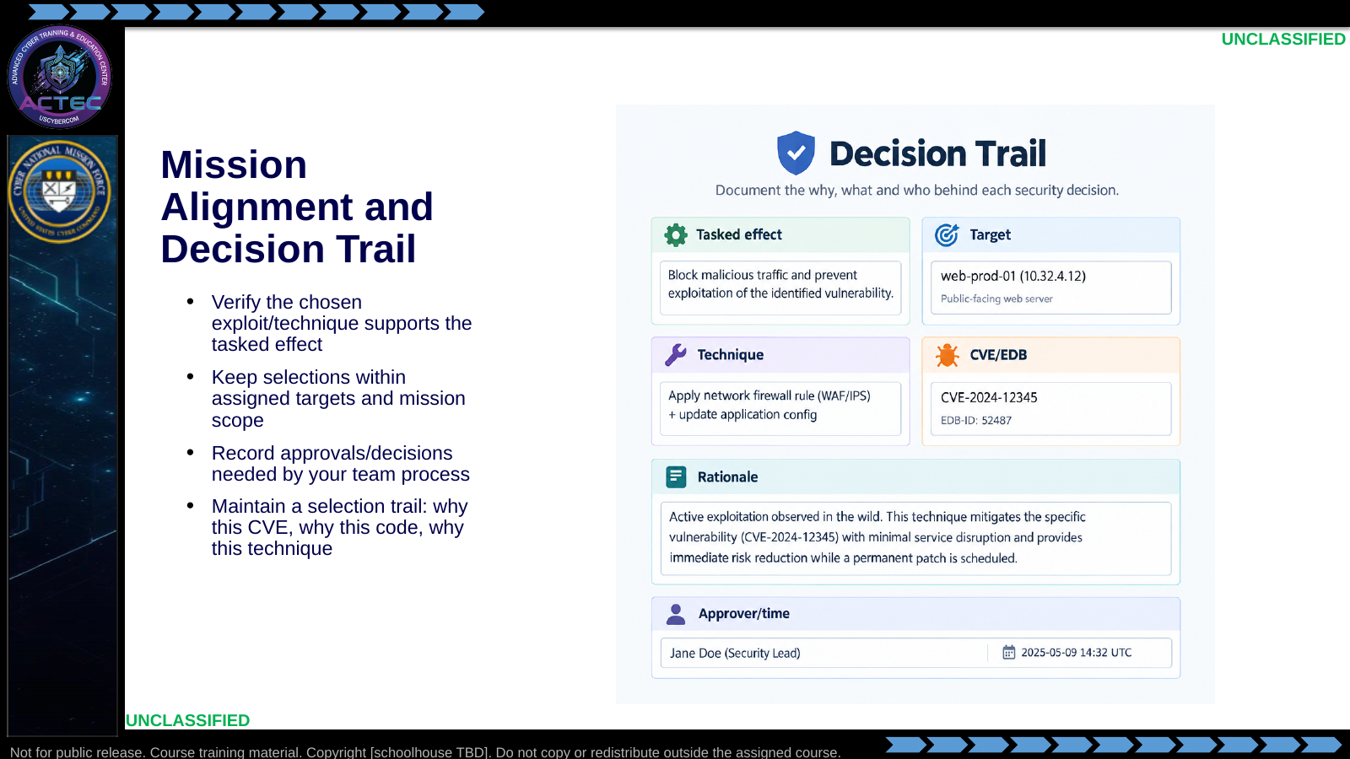  Slide 60: Mission Alignment and Decision Trail  Duration: 2 min | Say: - "Alignment beats cleverness."  - "If it does not support the tasked effect, drop it."  - "Stay inside assigned targets."  - "Your notes should let another operator understand the choice tomorrow."  Show: - Fill one example trail on the board.  Do: - Students copy the blank trail fields into their notebook for labs.  Ask (Q): What is the operational takeaway from this row?  Expected Response (A): Facilitation. Restate the Say/Do in operator terms. Do not invent a new teaching point.
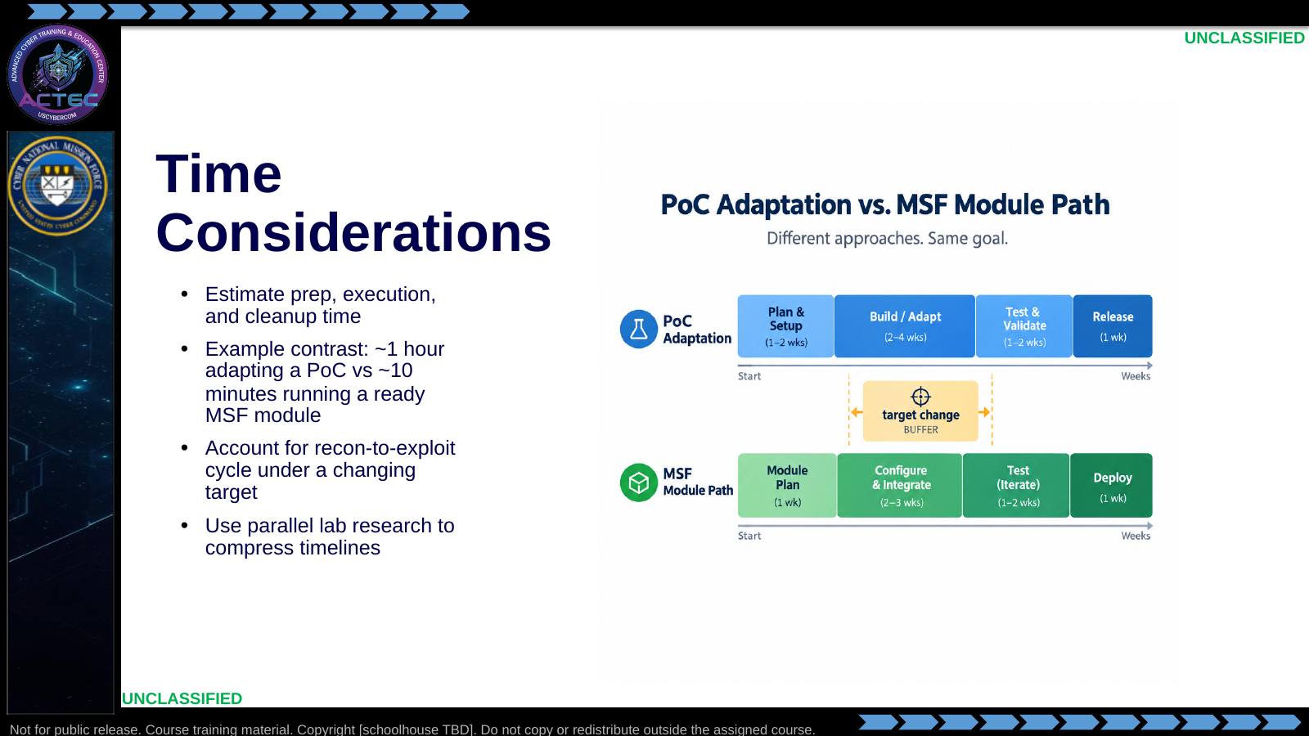  Slide 61: Time Considerations  Duration: 2 min | Say: - "Time is a suitability factor."  - "Adaptation cost is real."  - "MSF speed helps when modules fit."  - "Always leave buffer for target change after recon."  Show: - Compare the two timeline bars.  Do: - Ask which path they choose with 20 minutes until a mission window.  Ask (Q): What is the operational takeaway from this row?  Expected Response (A): Facilitation. Restate the Say/Do in operator terms. Do not invent a new teaching point.
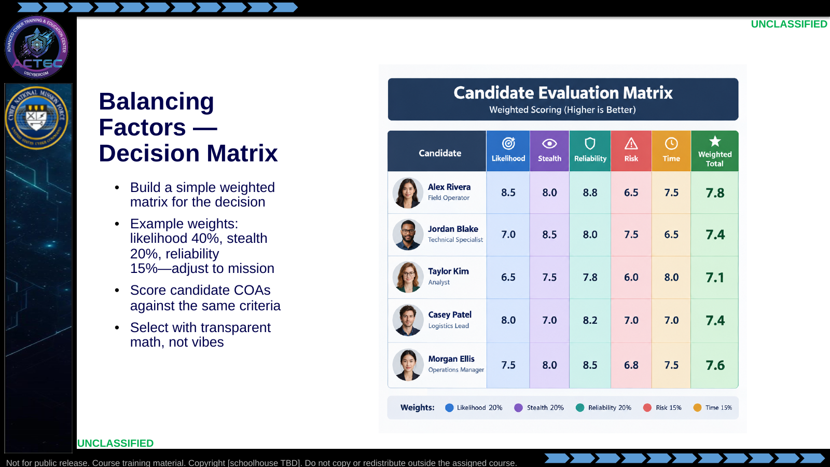  Slide 62: Balancing Factors — Decision Matrix  Duration: 2 min | Say: - "Make the tradeoffs visible."  - "Weights change with mission—stealth rises for long games."  - "Score at least two COAs."  - "The matrix supports the recommendation; it does not replace judgment."  Show: - Fill two candidate rows quickly.  Do: - Class scores a noisy high-success exploit vs a quiet lower-success PoC.  Ask (Q): What is the operational takeaway from this row?  Expected Response (A): Facilitation. Restate the Say/Do in operator terms. Do not invent a new teaching point.
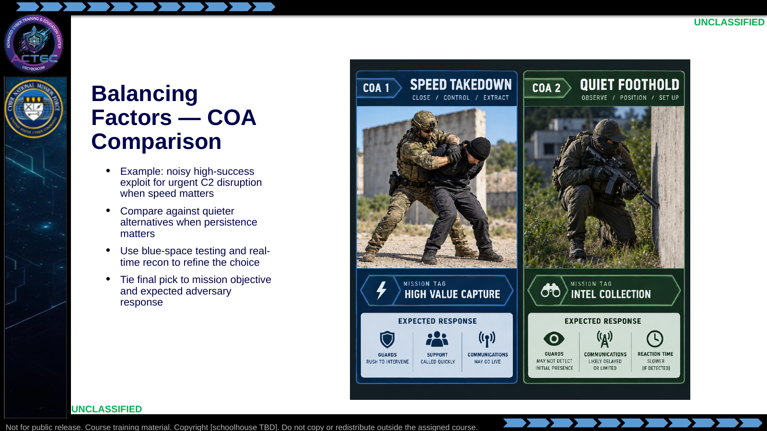  Slide 63: Balancing Factors — COA Comparison  Duration: 2 min | Say: - "Practical choice looks like this."  - "Urgent disruption can justify noise."  - "Long-game access usually cannot."  - "Re-check recon right before execution—targets move."  Show: - Compare the two COA cards.  Do: - Vote with hands on the urgent scenario; require one sentence rationale from a voter.  Ask (Q): What is the operational takeaway from this row?  Expected Response (A): Facilitation. Restate the Say/Do in operator terms. Do not invent a new teaching point.
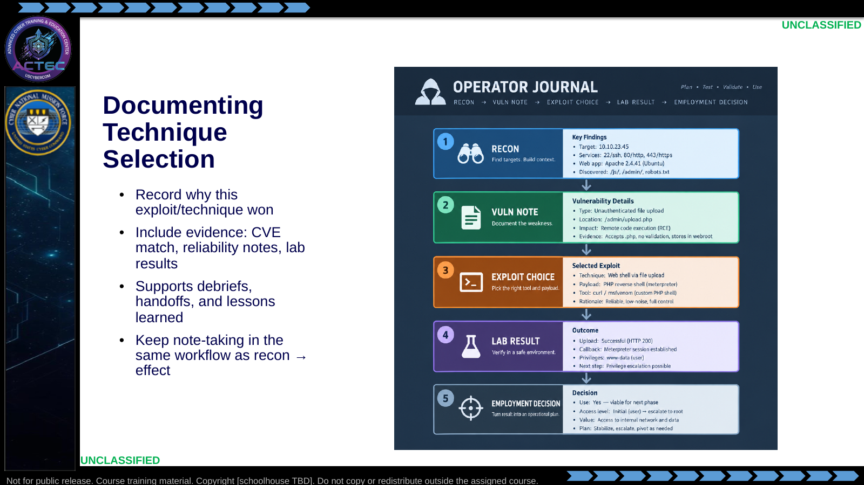  Slide 64: Documenting Technique Selection  Duration: 2 min | Say: - "If it is not written, the team cannot reuse it."  - "Evidence beats adjectives."  - "Documentation is part of execution quality."  - "Your future self is a customer of these notes."  Show: - Trace the journal chain.  Do: - Require a five-line selection rationale as the exit ticket before questions.  Ask (Q): What is the operational takeaway from this row?  Expected Response (A): Facilitation. Restate the Say/Do in operator terms. Do not invent a new teaching point.
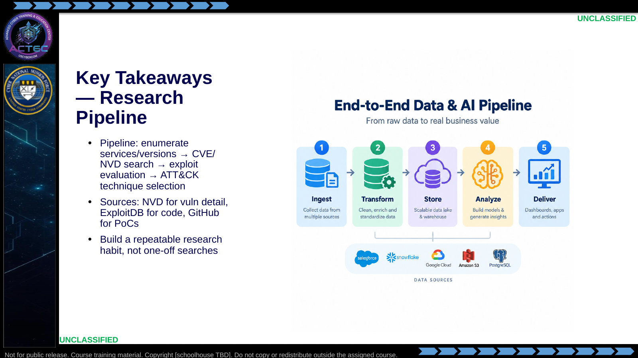  Slide 65: Key Takeaways — Research Pipeline  Duration: 2 min | Say: - "Takeaway one: order of operations."  - "Enumeration keys the search."  - "Databases and repos feed evaluation."  - "Technique selection makes it operational."  Show: - Trace the pipeline once more.  Do: - Students redraw the pipeline from memory in 60 seconds.  Ask (Q): What is the operational takeaway from this row?  Expected Response (A): Facilitation. Restate the Say/Do in operator terms. Do not invent a new teaching point.
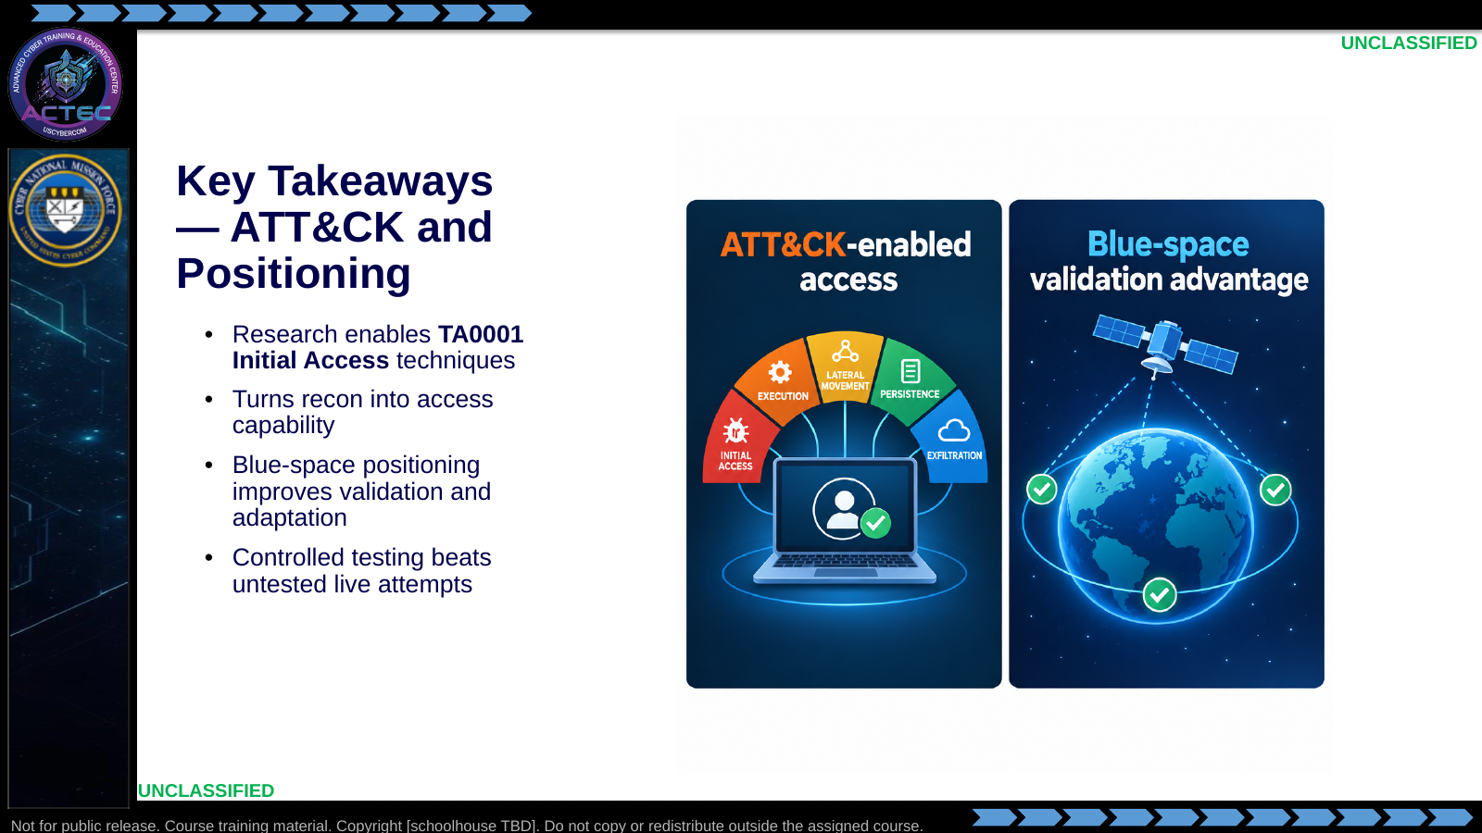  Slide 66: Key Takeaways — ATT&CK and Positioning  Duration: 2 min | Say: - "Takeaway two: ATT&CK keeps language consistent."  - "Takeaway three: where you plan and test matters."  - "Validation is part of access tradecraft."  Show: - Point both tiles.  Do: - Ask for one sentence linking their next keyboard practice to TA0001.  Ask (Q): What is the operational takeaway from this row?  Expected Response (A): Facilitation. Restate the Say/Do in operator terms. Do not invent a new teaching point.
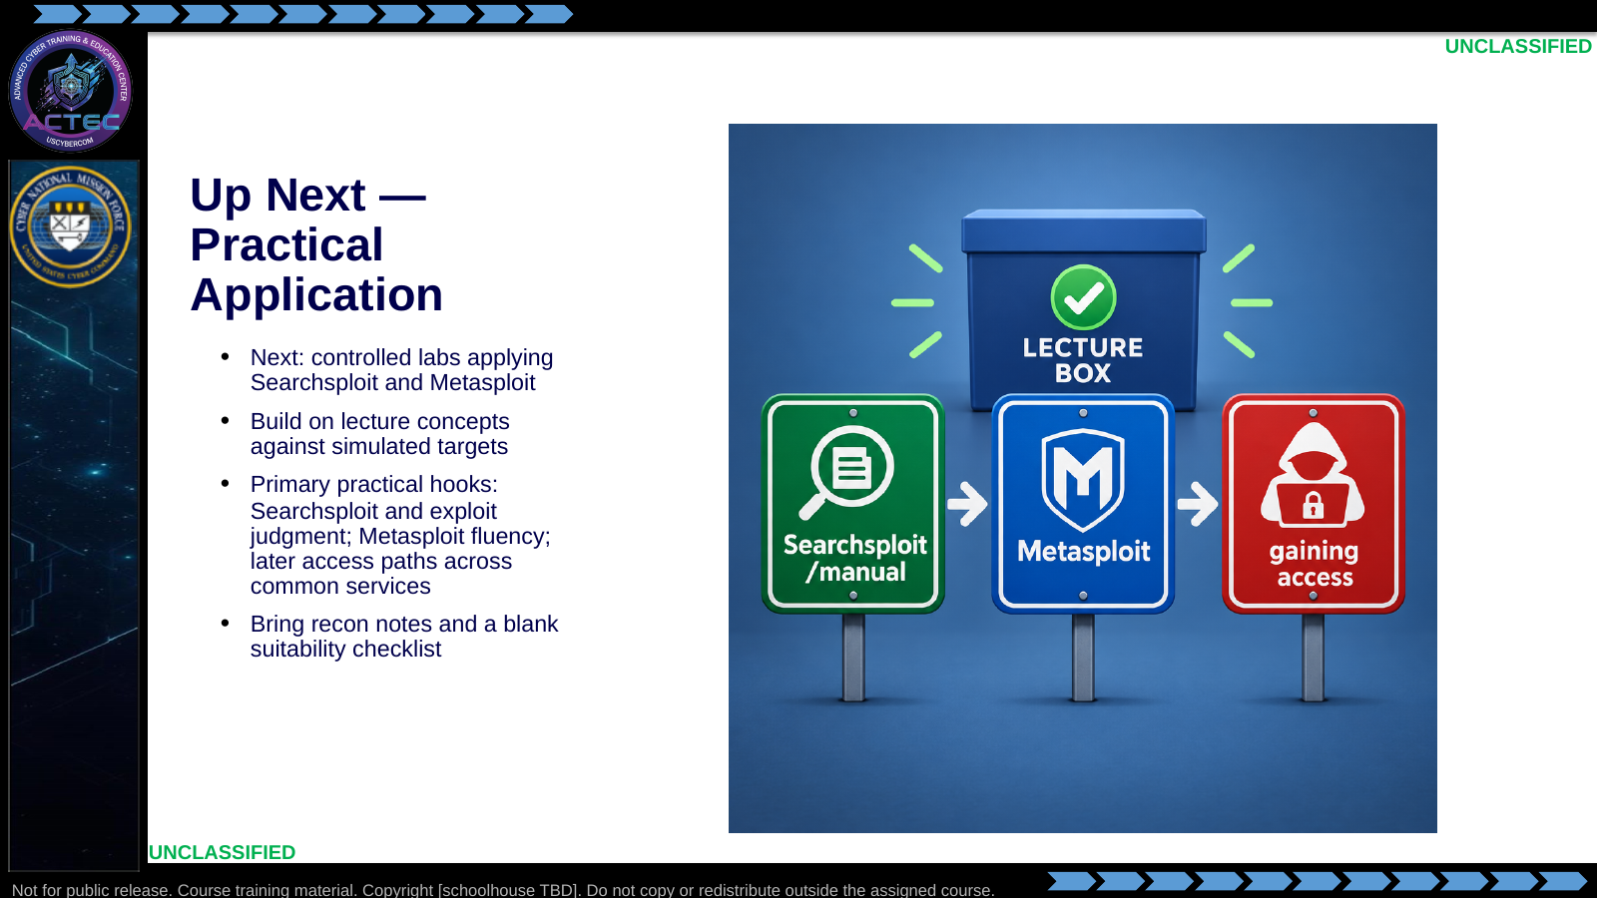  Slide 67: Up Next — Practical Application  Duration: 2 min | Say: - "Lecture ends; reps begin."  - "Searchsploit emphasizes exploit judgment."  - "Metasploit builds module-employment fluency."  - "Later access practice applies those techniques across common services."  - "Bring version evidence and your suitability checklist."  Show: - Point to each lab sign.  Do: - Hand out or display the Searchsploit/open-source brief pointer; break.  Ask (Q): What is the operational takeaway from this row?  Expected Response (A): Facilitation. Restate the Say/Do in operator terms. Do not invent a new teaching point.
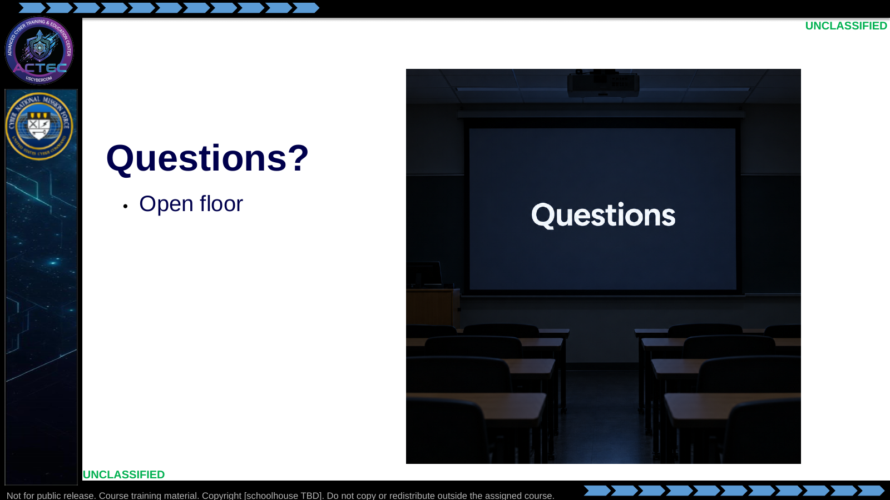  Slide 68: Questions?  Duration: 2 min | Say: - "Questions on the pipeline, sources, techniques, or suitability."  - "Tool errors and target IPs wait for the lab block."  Show: - Open the floor; note lab-specific issues for the lab block.  Do: - Take 3–5 questions; defer environment issues cleanly; release to break/lab.  Ask (Q): What question still has to wait for the lab block?  Expected Response (A): Tool errors and target IPs wait for the lab. Tradecraft questions belong here.  ---

4.3 Lesson summary
- B02.M02-open-source-ecosystem is executed as a generated lesson plan from this file.
- Assessment methods live on module.yaml; do not invent extra official ELOs.
- Later Searchsploit and Metasploit practice continues from the version evidence this session collects.

4.4 Questions and check on learning
- Ask (Q): Hold up one service and version from your last Nmap run.
- Expected Response (A): Facilitation. Use the Say/Do already on this row; do not force a single keyed answer.
- Ask (Q): What is the operational takeaway from this row?
- Expected Response (A): Facilitation. Restate the Say/Do in operator terms. Do not invent a new teaching point.
- Ask (Q): What version string from Nmap would you feed a search first?
- Expected Response (A): Facilitation. Use the Say/Do already on this row; do not force a single keyed answer.

5. Classification
Classification: UNCLASSIFIED

